**Predictive Models learnt:**

# **Linear Regression**:

**When to use it**: To predict a continuous variable. It is the simplest ML model. Linear Regression can be used to model a relationship between a continuous dependent variable and one or more than one independent variable. This will help us to predict the outcome as a function of the independent variable.

The predictive power of this model is not high. But it has great interpretation powers.

LR model can be easily explained and interpreted. This means it is very easy to explain how the dependent variable is changing on account of the change in independent variables

**Imp point: R-squared measures the scatter of the data around the regression lines**

**Impact of Outliers on the model**: If there are outliers in the independent variables, it impacts the best fit line as even one outlier (in case of a small dataset) can influence the fit of the regression line.

**Interpretation of the model from categorical variable:**

The interpretation of the impact of categorical variables on the dependent variable is relative. This means that if I have three categories in a categorical variable column. Then I will of course drop one to reduce the redundancy.

Sales = b0 + b1*X1 + b2*ShelveLoc_Good + b3*ShelveLoc_Medium

* Compared to Shelve location bad the sales will change by b2 if ShelveLoc is good keeping X1 constant

# **Some points to be noted about Linear Regression:**

1. R-Squared is called as coefficient of determination in case of SLR and coefficient of multiple determination in case of MLR
2. R-squared measures the strength of the relationship between the dependent variable and our model on a convenient 0-100% scale. In other words, it describes “how well the model is fitted to the data”
3. [Statisticians](https://statisticsbyjim.com/glossary/statistics/) say that a regression model fits the data well if the differences between the observations and the [predicted values](https://statisticsbyjim.com/glossary/fitted-values/) are small and unbiased. Unbiased in this context means that the fitted values are not systematically too high or too low anywhere in the observation space
4. Higher the standard error, less is the confidence with which the coefficients of the IVs were estimated. This means I will not be much confident in estimating the coefficient of the IV if the standard error for the independent variable is large

**Multicollinearity**: It is an issue which arises when there is a high correlation between the independent variables, it doesn’t affect the predictive power of the model but it does affect the standard error in estimating the coefficients and therefore we can’t rely much on the value of the coefficients of the independent variables thereby affecting the interpretability of the coefficients.

VIF can be used to check for the multi-collinearity in the variables.

**How to check if my model is reliable?**

1. Residuals V. Fitted values plots – We construct a scatter plot between residuals and the fitted values to assess if there is a pattern in the errors. It is expected from the errors in the predictions to be random not deterministic. Therefore, if the errors are smaller for smaller values of X/fitted values, and larger for larger values of X/fitted values, this issue makes the variance not constant and is called as Heteroscedastic. Presence of any kind of patterns or heteroscedasticity indicate some non-linear relationship between independent and dependent variables

**Heteroscedasticity**: Residual plot is the plot between the residuals and the predicted response variable. In case of SLR, the component on X-axis can also be the predictor variable. It is defined as the presence of non-constant variance in the residuals.

**Consequences of Heteroscedasticity**: Heteroscedasticity affects the standard error of the estimates. However, it affects only if the Heteroscedasticity is fairly large.

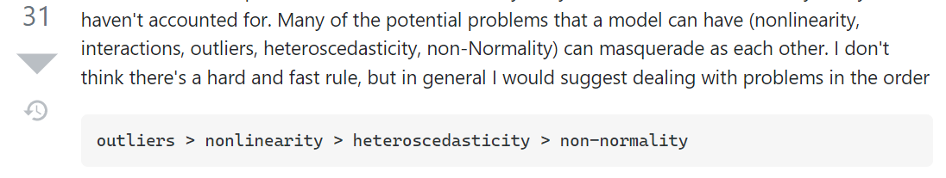

**Note –** You cannot trust the p-values in the presence of multicollinearity. Multicollinearity reduces the statistical significance of your model

**Assumptions of linear regression:**

1. Linearity – There should be a linear relationship between the response variable and the predictor variables. If not, we can try transforming the variables before fitting a linear regression
2. Normality of errors – Errors should be normally distributed. As a consequence, for moderate to large sample sizes, non-normality of residuals should not adversely affect the usual inferential procedures. This result is a consequence of an extremely important result in statistics, known as the central limit theorem.
3. Homoscedasticity - A further assumption made by linear regression is that the residuals have constant variance. That is, their variance does not change across different levels of the predictors. In contrast to the normality assumption, if the residuals do not satisfy the constant variance assumption, standard errors and confidence intervals (based on standard formulae) will be adversely affected, irrespective of whether the sample size is large or not.

**What to do if errors are heteroscedastic** – Transform the dependent variable. Use Box-cox transformation

1. Outliers – It is preferred not to have many outliers. A few won’t be a problem
2. Multicollinearity –

**Box-cox** and **Yeo-Johnson** transformers are used to make any distribution gaussian-like. Whenever we have a heteroscedastic data, which we can check for by using white’s test, we can then apply power transformer methods such as Box-cox and Yeo-Johnson for making it homoscedastic.

Box-cox technique is used when the data doesn’t have zero or negative values. But when it has zero or negative values as well, we use Yeo-Johnson.

What happens in Box-cox is a lambda is calculated such that the distribution of the data (an array) becomes gaussian-like. Every data point(xi) changes into either one of these two values.

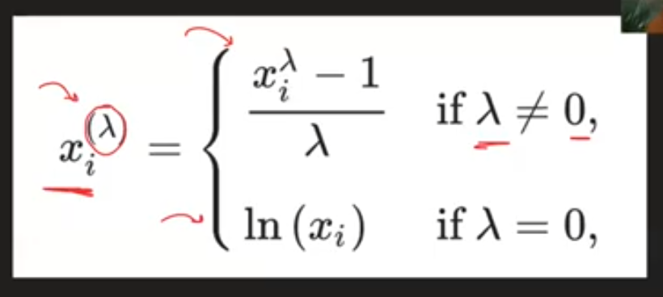

What happens in Yeo-Johnson?

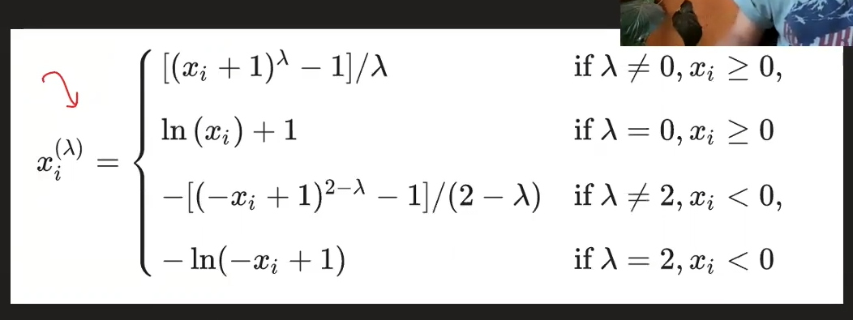

ColumnTransformer is another function to transform one specific column of a dataframe. You need to input a tuple consisting of (name,FunctionTransformer,column) in a list, if remainder argument is kept as passthrough then it passes through the other columns untouched and do the transformation on the column in the tuple.

For Right-skewed data: Use log

For left-skewed data: Use squared function

[How to fix heteroskedasticity](https://statisticsbyjim.com/regression/heteroscedasticity-regression/)

**Steps for Linear regression**

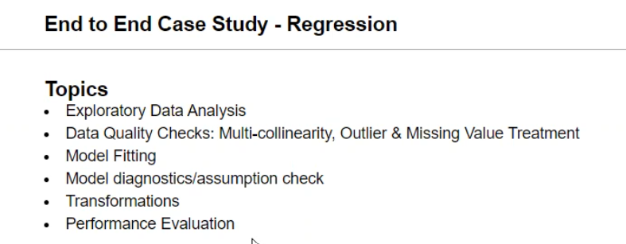

**Types of performance evaluation in Linear regression**:

MAE ; [MAPE](https://www.statology.org/how-to-interpret-mape/) ; RMSE ; MSE ; [RMSLE](https://medium.com/analytics-vidhya/root-mean-square-log-error-rmse-vs-rmlse-935c6cc1802a).

1. RMSLE is robust to outliers
2. RMSLE incurs larger penalty on underestimation than overestimation

[Robustness of MAE, MSE, and RMSE](https://towardsdatascience.com/comparing-robustness-of-mae-mse-and-rmse-6d69da870828)

**Interpretation of a model where logarithmic transformation was done on dependent or independent variable**

1. **Only the dependent/response variable is log-transformed**. Exponentiate the coefficient, subtract one from this number, and multiply by 100. This gives the percent increase (or decrease) in the response for every one-unit increase in the independent variable. Example: the coefficient is 0.198. (exp(0.198) – 1) * 100 = 21.9. For every one-unit increase in the independent variable, our dependent variable increases by about 22%.
2. **Only independent/predictor variable(s) is log-transformed**. Divide the coefficient by 100. This tells us that a 1% increase in the independent variable increases (or decreases) the dependent variable by (coefficient/100) units. Example: the coefficient is 0.198. 0.198/100 = 0.00198. For every 1% increase in the independent variable, our dependent variable increases by about 0.002. For x percent increase, multiply the coefficient by log(1.x). Example: For every 10% increase in the independent variable, our dependent variable increases by about 0.198 * log(1.10) = 0.02.
3. **Both dependent/response variable and independent/predictor variable(s) are log-transformed**. Interpret the coefficient as the percent increase in the dependent variable for every 1% increase in the independent variable. Example: the coefficient is 0.198. For every 1% increase in the independent variable, our dependent variable increases by about 0.20%. For x percent increase, calculate 1.x to the power of the coefficient, subtract 1, and multiply by 100. Example: For every 20% increase in the independent variable, our dependent variable increases by about (1.20 0.198 – 1) * 100 = 3.7 percent.

# **Logistic Regression:**

* Primarily used for Binary classification problems. Though, with some adjustment we can use it for multiclass as well.
* Most of the ML algorithms work equally well for binary and multiclass
* Ideally, we would like a binary classification model to tell us the probability of an observation belonging to a class
* In order to bound the y given below, we turn towards an exponential function described below

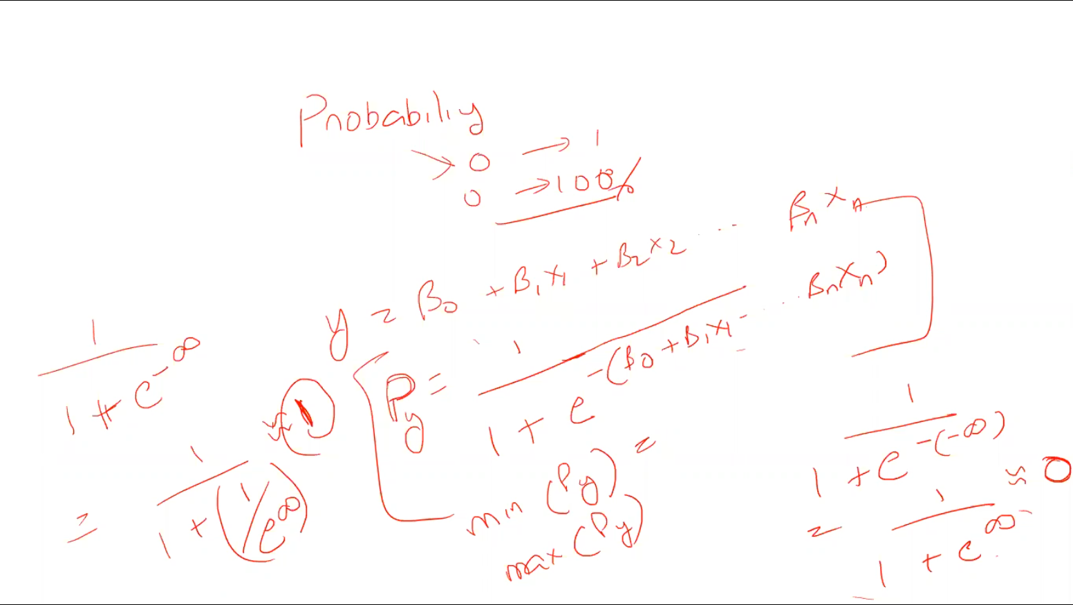

* The Py described above is called as sigmoid function

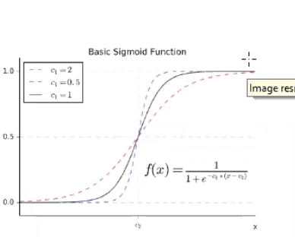

**Interpretation of logistic regression**

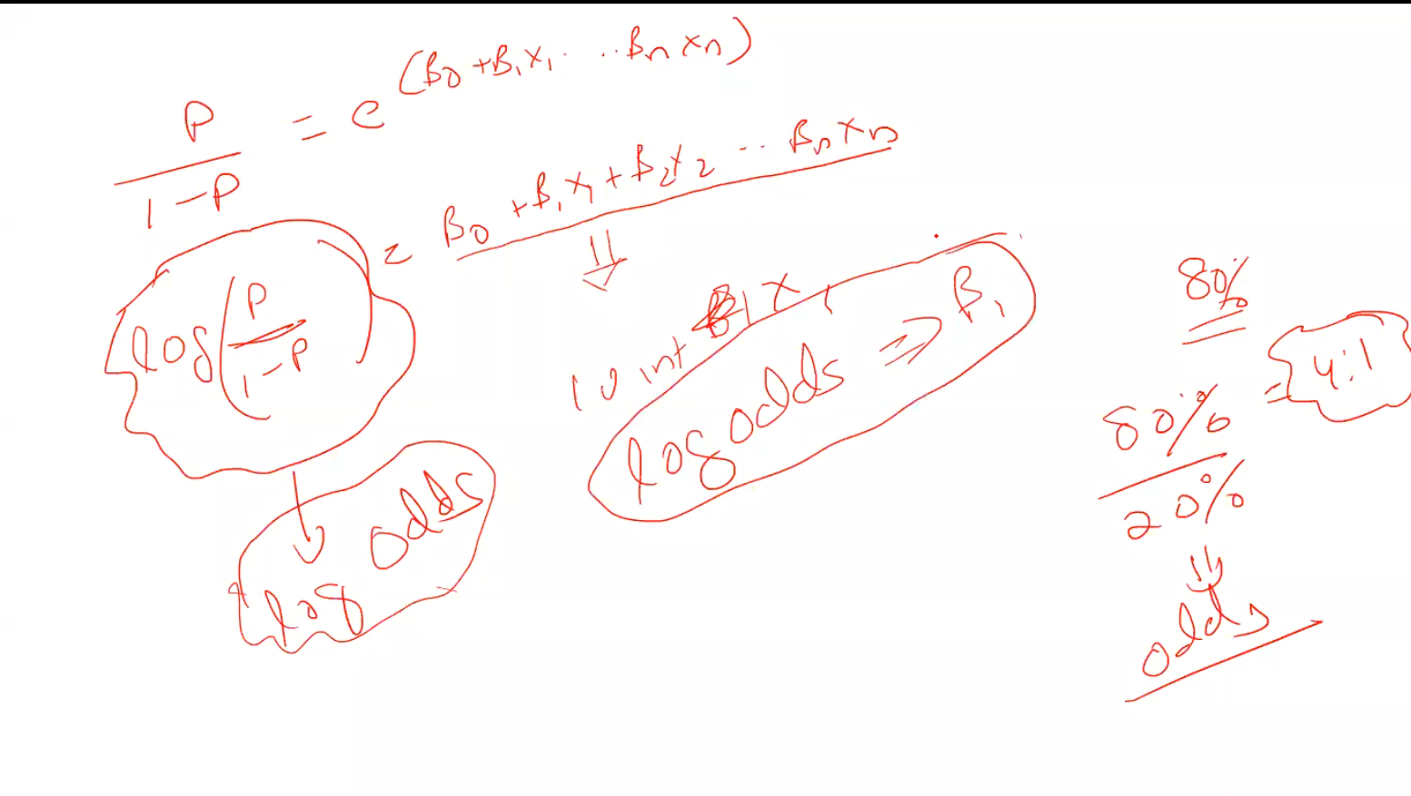

* If I observe the equation above i.e.,

Log(P/1-P) = (β0 + β1*X1 + β2*X2 +……+βn*Xn).

* Interpretation is if I increase X1 by 1 unit then the log odds will increase by β1 keeping other factors constant.
* Odds is defined as the ratio of (probability of an event happening) & (probability of an event not happening). It is also known as likelihood of an event

If my X1 independent variable increases by 1 unit, then keeping other independent variables constant, I can say that the odds of the event happening (whether the customer will buy or not) will increase by β1

Also, if my variables are scaled, I can draw a comparison about which variable is bringing most of the change in the likelihood of the event happening

**Logistic regression equation for interpretation**

Log(P/1-P) = (β0 + β1*X1 + β2*X2 +……+βn*Xn).

**Loss function**

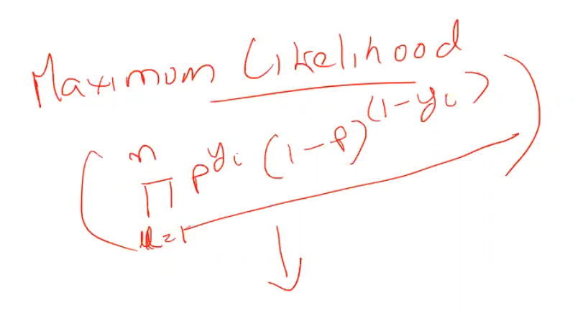

Yi can be 1 or 0. Beta coefficients are derived in such a way that the loss function is minimized.

**Positive class –** The class that we are interested in predicting

**Confusion matrix** –

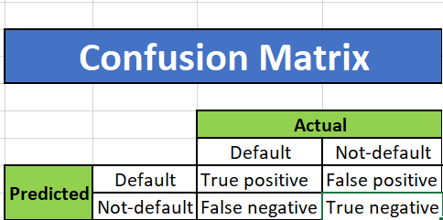

**Performance Metrics**:

1. Accuracy –

**Accuracy =** Total no. of correct predictions Total no. of predictions done

If there is a class imbalance in the dataset, accuracy doesn’t make much sense. In those cases, the class of interest is in minority and thus we can get overall high accuracy just by nullifying the model or by just assuming the majority class to be the outcome of all the observations.

Positive class is typically the class of interest

1. Precision – Computing how precise my positive predictions are.

**Precision =** True positive/ (True positive + False positive)

**Simple English definition of Precision -** So, if my precision is high then there is a good chance that my predictions are precise, this means if my model says that “this person will default on the loan” and it has high precision, then there is a good chance that “**the person will actually default**”.

1. **Recall** – How many positive classes i.e., classes which were actually positive was I able to capture.

**Simple English definition of Recall -** So, if my recall for positive class is low then the model is missing out on a lot of actual positives i.e., it is unable to detect them as positives and is misclassifying them as negatives thus False negatives become high

**Recall/Sensitivity =** True positive/ (True positive + False negatives)

1. **Specificity** – Specificity. It is the metric to know how many negative classes am I classifying correctly. If specificity is high, I can say that it is classifying my negative classes correctly and is not much misclassifying the negatives as positives.

**Specificity =** True negative/ (True negative + False positive)

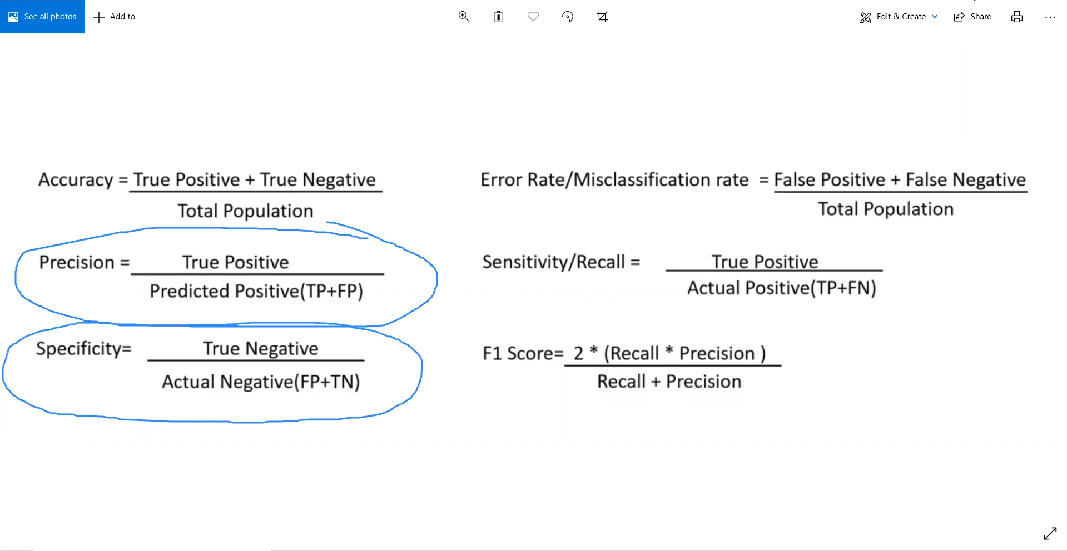

**Advantage of working with Probabilities** – Suppose the stakeholder comes up to you and says we have limited resources to pitch our bank-marketing product and we can make only 10,000 calls to the customers. So, you can then utilise the predict_proba method to sort the dataframe by their probability of buying the product and select top 10,000 customers.

**Area under the curve:** This is a visual way of assessing how well a model is doing

AUC of a good model falls between **50% and 100%**.

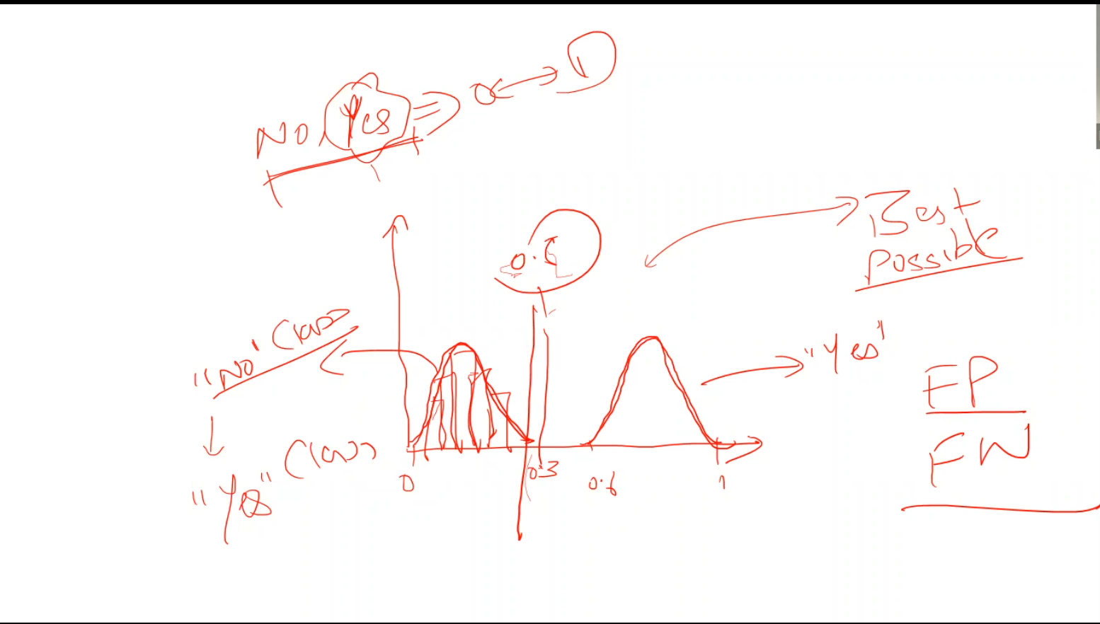

**ROC and AUC**

* It is not influenced by imbalance in the dataset
* Visual way of understanding how well the model is doing
* ROC stands for Receiver operating characteristics
* AUC stands for Area under curve

**AUC** – The intuition behind AUC is calculating the overlap between the two probabilities in classifying the classes. It is a curve between TPR and FPR. **When AUC is 0.7, it means there is a 70% chance that the model will be able to distinguish between positive class and negative class**

**TPR** can be termed as True Positive Rate which is equal to Recall and **FPR** can be termed as False positive rate and is equal to (FP/(FP+TN))

**AUC** plots TPR against FPR for different values of cut-off

AUC of 50% is as good in classifying the classes as would a coin do.

**Intuition –** AUC of 50% would mean that as soon as TPR (or Recall) increases the FPR increases as well subsequently lowering the Precision. That is the only way of improving the recall. AUC above 70 is a decent model.

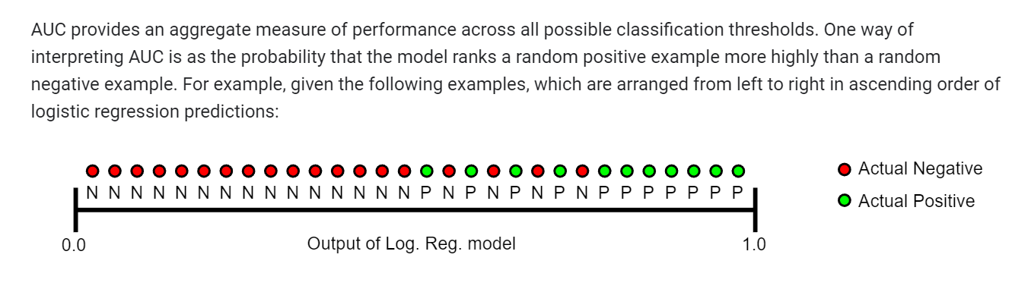

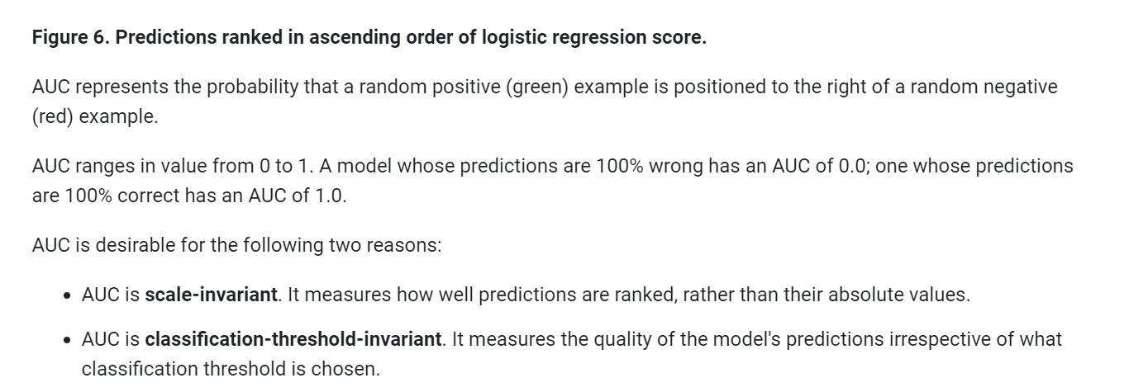

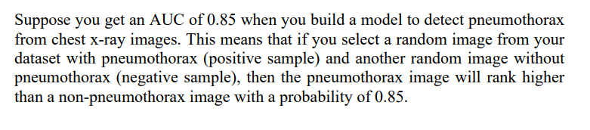

**How to improve AUC?**

In order to improve AUC, it is overall to improve the performance of the classifier. Several measures could be taken for experimentation. However, it will depend on the problem and the data to decide which measure will work.

(1) Feature normalization and scaling. Basically, this is a method that improves the performance of the linear (logistic) model.

(2) Improve class imbalance. In classification problems, a bunch of them have imbalance classes. Setting class weights, or performing upward/downward sampling will help.

(3) Optimize other scores. Defining the right score for the problem, and optimize the score will help the prediction performance.

(4) Explore different models. Among the classification model, choose the model that has the best performance on the problem.

(5) Tune the parameter through grid search. Grid search is an automatic way to tune your parameter.

(6) Error analysis. Go back to check the false positive and false negative cases and find the reasons for this.

(7) Include more features or fewer features.

(8) There are also researches on optimizing AUC scores directly through investigating the relationship of AUC and error rate, or with the models, leading to a more straightforward but also more complicated analysis.

**NOTE:** Linear and Logistic regression don’t overfit

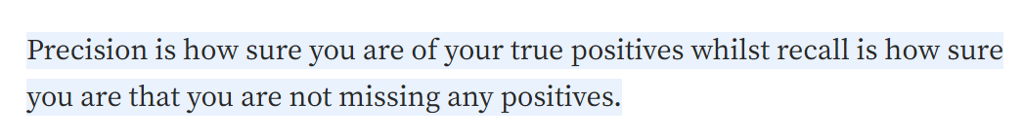

**AUPRC**: AUPRC is the most preferred performance metric when dealing with Imbalanced dataset this is because it does not account True negatives into calculation. Because PR curves don’t use true negatives anywhere, the AUPRC won’t be “swamped” by a large proportion of true negatives in the data. You can use AUPRC on a dataset with 98% negative/2% positive examples, and it will “focus” on how the model handles the 2% positive examples. If the model handles the positive examples well, AUPRC will be high. If the model does poorly on the positive examples, AUPRC will be low.

# **Decision trees**: [**Detailed explanation of CART**](https://sefiks.com/2018/08/27/a-step-by-step-cart-decision-tree-example/)

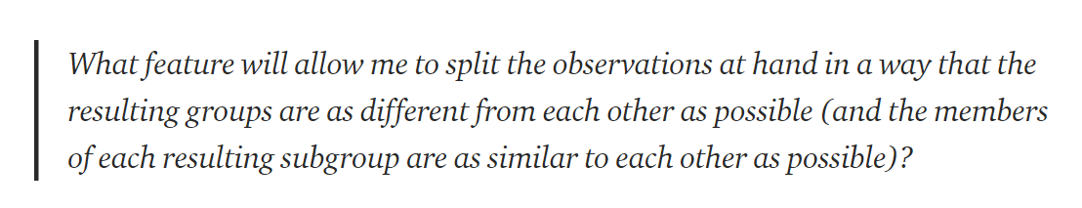

Gini Impurity **tells us what is the probability of misclassifying an observation**. Note that the lower the Gini the better the split

Classification types of models – These models have to have categorical dependent variable and categorical and/or continuous independent variables

Some classification models allow categorical variables but some require us to transform categorical variable into continuous variables

* Nominal to Continuous – One hot encoding. Also, known as Dummy variables
* Ordinal to Continuous – Label encoding

We shall cover 3 distinct algorithms.

**Modern Machine learning algorithms:**

Unlike the traditional algorithms like Linear Regression and Logistic regression, these modern algorithms do not have any underlying assumptions which is why they are termed as modern ml algorithms

1. Decision trees – CART: Classification and Regression trees. CART is a binary decision tree. CART is a binary decision tree that divides a node into two leaf nodes repeatedly
2. Ensemble method – Random Forest
3. Artificial Neural Network for ML

Please note that all of these are classification methods. We will also study evaluation techniques to validate model’s performance

# **How to use Decision trees for Classification?**

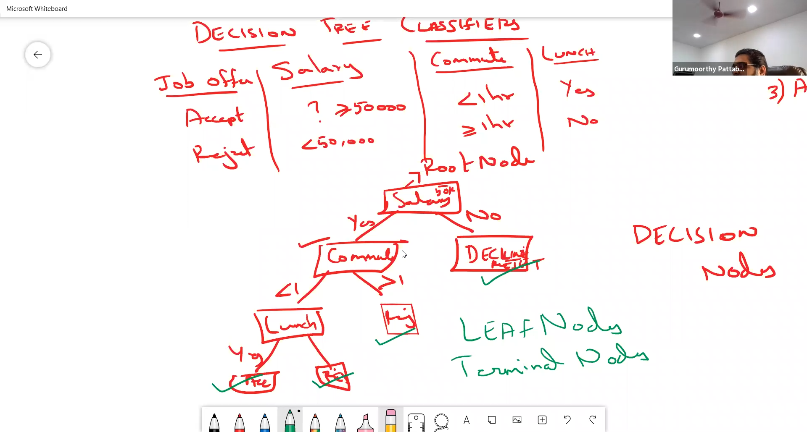

There are three types of nodes in a decision tree:

1. Root Node – This is the first node of a decision tree from where the decision-making starts. It does split further.
2. Decision nodes/Internal nodes – All the nodes (apart from the root node) which split further are called as decision nodes.
3. Terminal/Leaf nodes – These nodes do not split further in a decision tree

When every node split into two nodes, we call that decision trees “Binary split decision tree”. CART modelling technique always splits every node into two nodes; hence the decision trees are always “Binary split”.

**Parent nodes:** If I select a slice from a decision tree which has one decision node splitting into two decision or terminal nodes, then that decision node which was split further will be termed as Parent node and the two nodes into which it was further split will be termed as **child nodes**

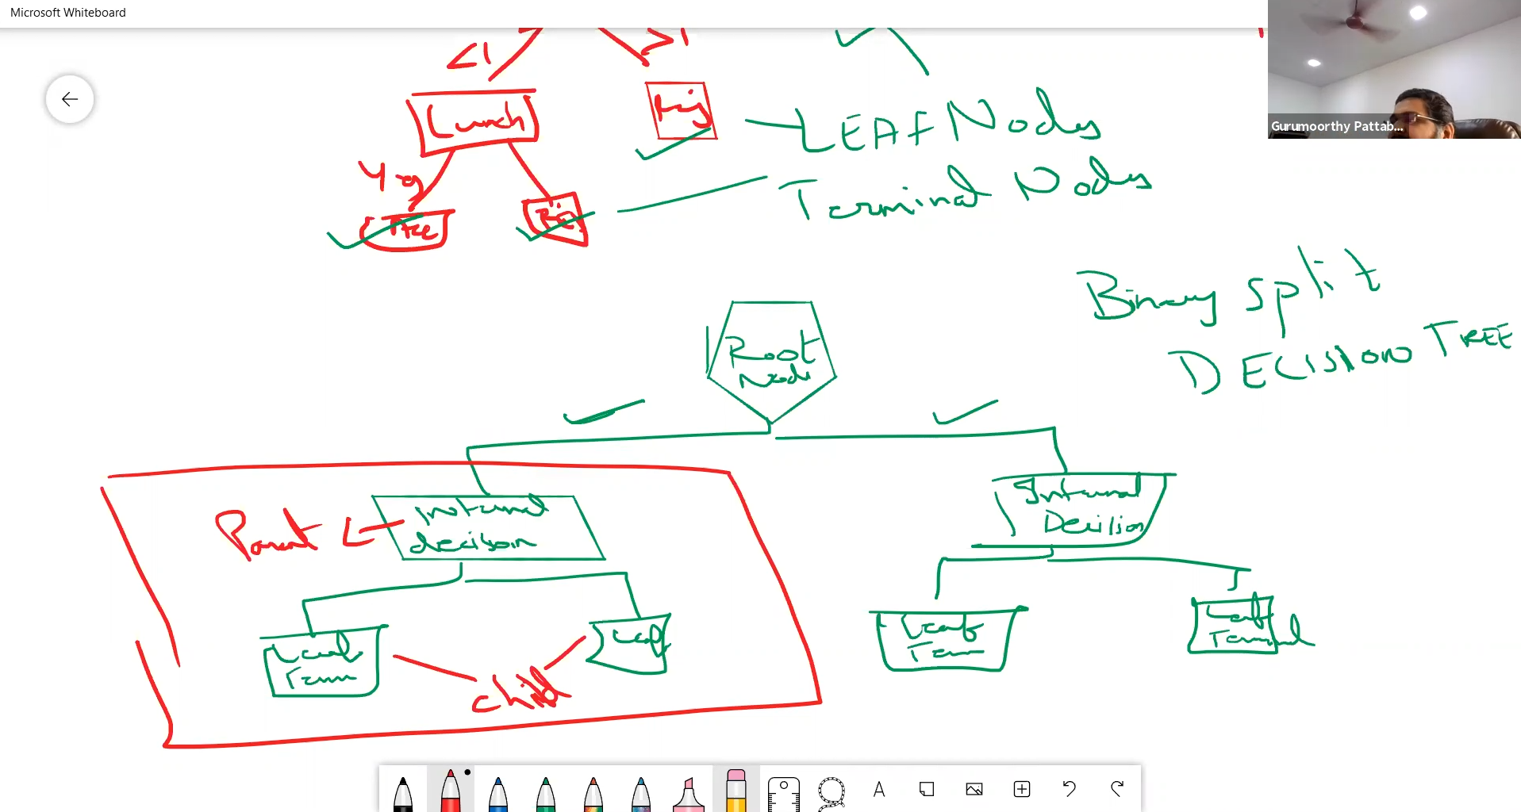

**Pruning a decision tree:** When to know stopping a decision tree. This will be discussed later.

* **How does Decision tree model work**?

**Step#1 –** We train the model.

**Step#2 –** The future observation traverses through the decision tree basis the value of other independent variables

**Step#3 –** Then once it stops onto a terminal node. We then look out for the proportion of classes of the dependent variable basis the training data in that node. Then the class proportion which is higher, that same value is attributed to the future value

* **How to choose the best variable to split a decision tree**:

There are two logics to find out the best variable to split a decision tree:

1. Gini Impurity – More the impurity, higher the Gini impurity
2. Entropy: It is the quantifiable version of disorder in the data. More the impurity, higher the entropy.

Those columns are chosen for which the information gain or gini gain is higher.

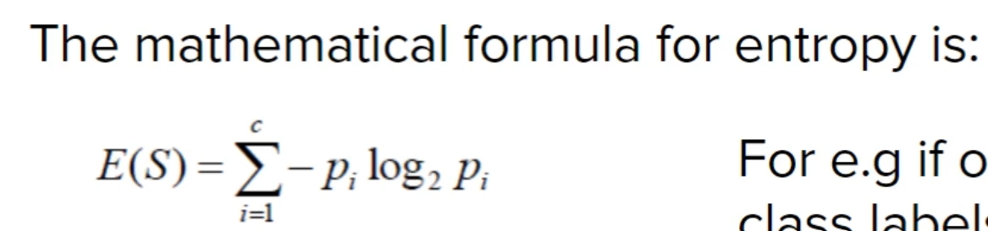

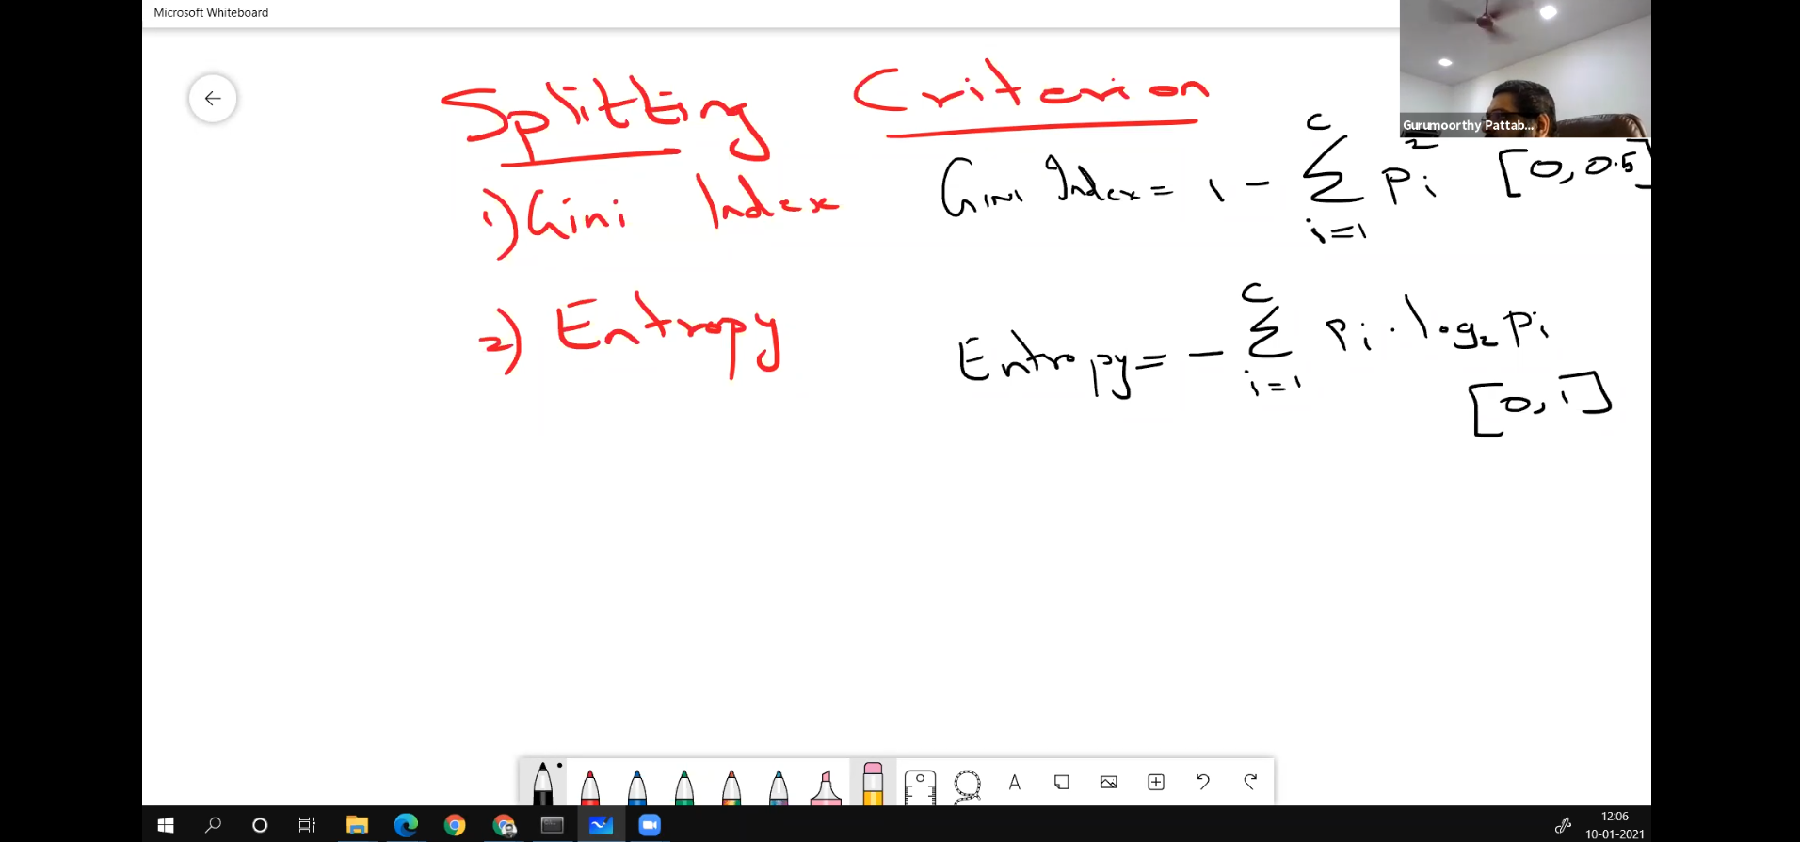

Steps to use Gini index logic:

**Logic -** Find out Gini gain for all the independent variables, whichever independent variable has the highest Gini gain will become my variable to split the data

**Formula to find Gini gain : Gini indexparent – Weighted Avg. [Gini indexchild]**

**Note:** Independent variables can be discrete and continuous in case of decision trees. But python doesn’t accept the “object” datatype and thus, we need to convert it into numerical datatype. It is a limitation of python.

Gini index calculation is faster but entropy calculation is slower.

We will be assigning numerical values to each of the categorical values.

**Important points**:

1. Check for null values.
2. When we work with Decision trees, it can work with both kinds of data types i.e., categorical and continuous
3. When we call the decision tree function in python, it doesn’t accept object data types. It accepts only integer data types, so I will have to assign a numerical code to each of the classes of a categorical variable
4. Always study your target column, always look for the value counts of different classes. When there is a significant imbalance in the class information, the models tend to perform poorly
5. For descriptive analysis, we can look at pairplot
6. To create a simulation of testing, we split our data into train and test sub-datasets in the proportion of 70% and 30%
7. We can also visualize a decision tree using tree.plot_tree
8. **Gini importance**: We can use this output attribute of our decision tree model to find out which variable was the most important to separate the purities and impurities. **Gini importance** of a feature or a variable is the normalized total reduction of the gini criterion brought by that particular feature. The reason it is normalized is that if I add up the gini importance values of all the features, the sum will be 1.

**Standard benchmark difference in accuracy of Train and test should not be more than 15%. If test accuracy is more than 15% from train accuracy then I will call the model overfitted.**

**Pruning in a decision tree** is necessary to increase the confidence in prediction. This is because if I allow my tree to grow indefinitely then each of the terminal node will have 1 observation in it. Now if I use such model for prediction then I will have to rely on just that 1 observation. This lowers my confidence in the model. Pruning is done to ensure that I have adequate number of records in my terminal nodes so I have some confidence in my predictions.

**Regularization of a decision tree:** Sometimes there are some problems in a decision tree, regularization helps us to resolve those problems.

This is the concept of pruning a decision tree in such a manner so that there are substantial number of records in each and every terminal node in order to have confidence in my predictions.

**Note –** Pruning helps to avoid overfitting

It is ideal to have a decision tree shaping up as a pyramid or triangle. The picture

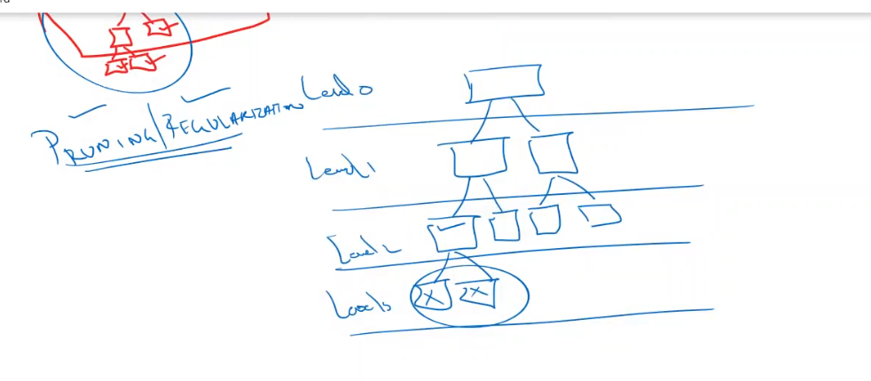

# **Pruning a decision tree:**

**Note: Min_sample_leaf = There should be at least 1%-3% records(of the training dataset) in every terminal node if it is less than 1% my model might become overfitted.**

**Min_sample_split = 2 to 3 times of Min_sample_leaf**

**Min_sample_split:** It is the minimum number of records that should be there in a node to qualify splitting it into further child nodes.

**Min_sample_leaf**: It is the minimum number of records that should be in a terminal node before it is termed as a leaf/terminal node. If the node has lesser records than this, then the complete split gets cancelled and the tree stops at the parent node of these two child nodes

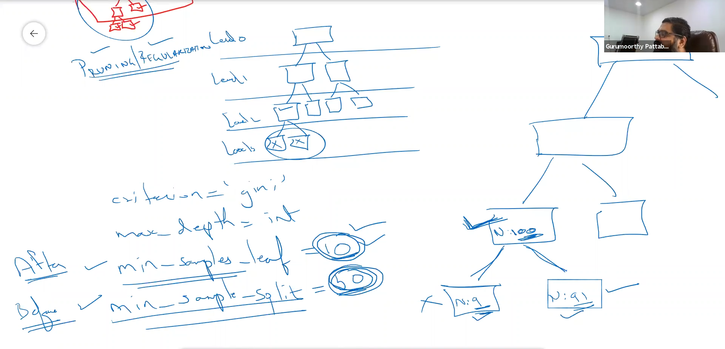

**Note:** If I use extremely large datasets. For instance, 1,000,000 of records then it is not advisable to use decision trees. We opt for RF, ANN

**How to find out the optimal values of hyperparameters and best model?**

Use GridSearchCV

**Explanation:** GridSearchCV is an automated method to find out the best values of hyperparameters such as max depth, min samples leaf, and min samples split. Cross validation function (cv) is also known as k-fold cross validation. This is because it splits your training data into k-parts(value of k is given by the user) to check for the different combinations that are possible to find the best model

## **Parameter vs Hyperparameter**

A parameter is a value that is learned during the training of a machine learning (ML) model while a hyperparameter is a value that is set before training a ML model; these values control the learning process. Parameters change during the learning process while hyperparameters are constant. Parameters are learned automatically while hyperparameters have to be set manually.

**Random forest algorithm:**

**What is an ensemble method?** – An ensemble method is “building plenty of simple models and then taking the aggregate result of all of these models to make a prediction”.

An assumption of an ensemble method is “wisdom of multiple simple models is better than the wisdom of just one model”.

**Techniques of ensemble method:**

1. Bagging/Bootstrap aggregation – available in sklearn
2. Boosting - available in sklearn
3. Stacking or Blending – manual methods

**Bagging**:- Random forest is type of a bagging ensemble technique.

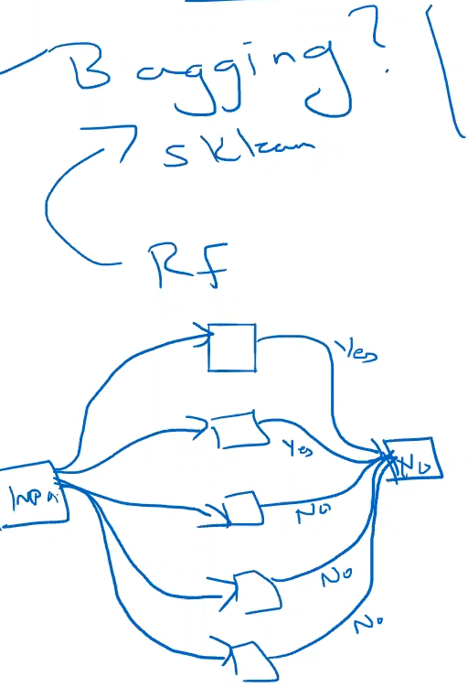

**Notes on how does bagging technique work?**

1. In a bagging technique, an input is fed into several estimators/models. Then each model prescribes an output. After that, basis the majority opinion, the final output is chosen
2. All the inputs are given in parallel to all the estimators i.e., simultaneously to the models.
3. All the estimators i.e., all the models will be same kind. If I am choosing Decision tree then all the estimators will be decision trees. It happens the same with bagging and boosting. However, in stacking/blending ensemble technique, all the estimators are different
4. **Within bagging classifiers** if I am choosing decision trees, the bagging model is called as Random forest
5. To give different inputs to all the models, random forests utilise a technique called random sampling with replacement. In Random sampling, a sample from input (with the same size) is chosen with replacement. Some rows will be in the bag and some will be out of the bag.

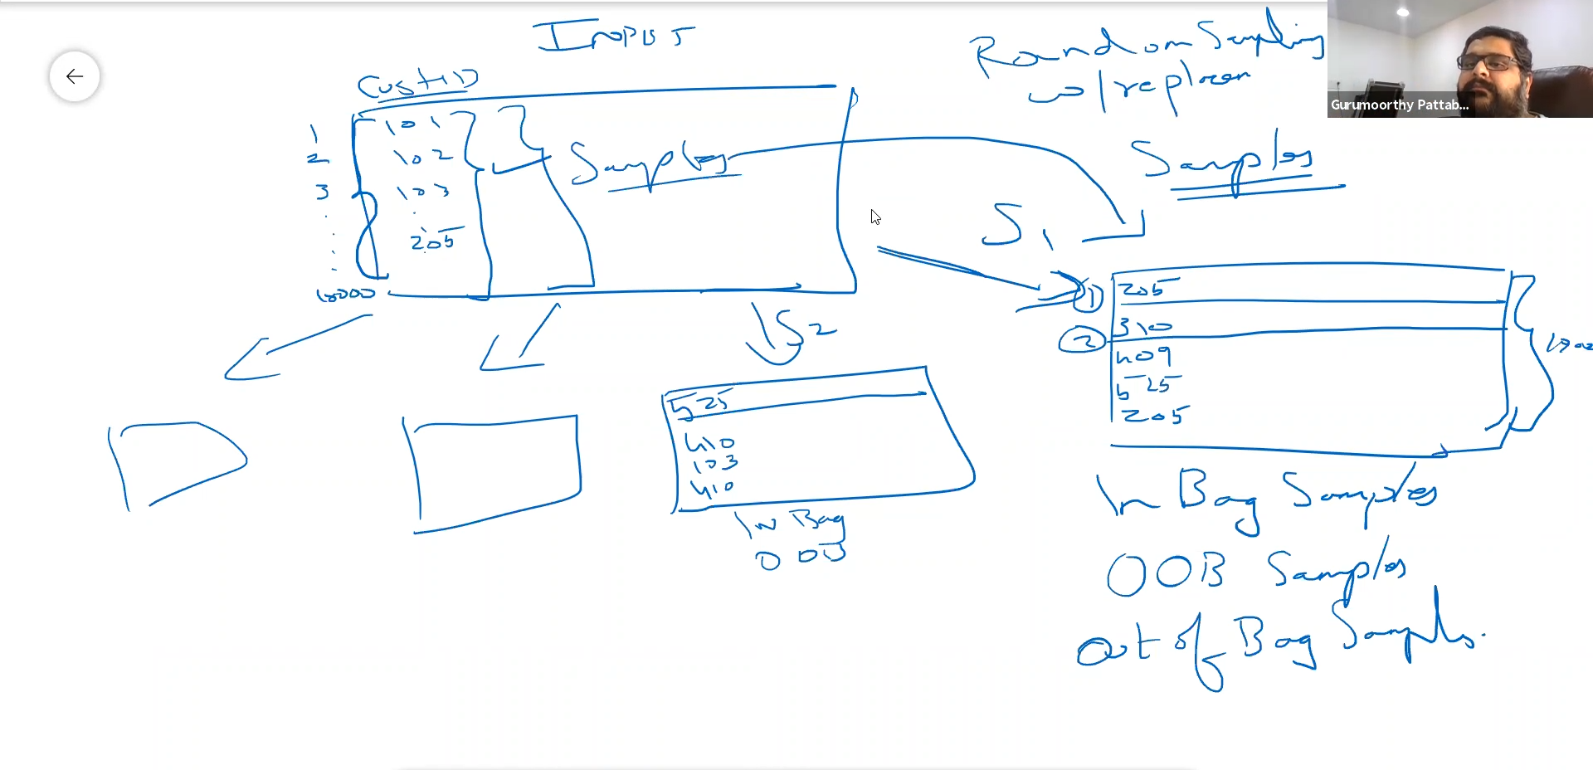

* **Why are decision trees preferred in ensemble methods?**
* This is because of their high variance models. When a Decision tree split happens, the variable that is chosen
* **Why DT is a greedy algorithm** : Tree splitting is locally greedy — At each level, tree looks for binary split such that impurity of tree is reduced by maximum amount. This is a greedy algorithm and achieves local optima. It may be possible, for example, to achieve less than maximum drop in impurity at current level, so as to achieve lowest possible impurity of final tree, but tree splitting algorithm cannot see far beyond the current level. This means that Decision Tree built is typically locally optimal and not globally optimal or best

**High Variance –** The variation in the accuracy of different models is called variance. **High bias –** If the cross-validation models have more or less same accuracy, then it will be low variance model but if I then check the accuracy of the best model, if it turns out to be less than average of them or exact value of them, then we say model is overfitted. If it is significantly higher, then it is underfitted. High bias is *overfitting* and *underfitted.*

**Max features:** When we create a random forest by assembling multiple decision trees. We intend to have the inputs of trees not similar to one another as well as we’d like the decision trees not to be correlated with one another.

The input requirement can be achieved by Random sampling. But, the requirement of Decision trees not to be correlated with one another can be achieved by max features. It states that if I have 10 features in my overall dataset then if I keep my max features as 7, then for every decision tree those 7 features are chosen randomly. This process happens at every DT.

**How to choose the optimal number of max features? –** GridSearch

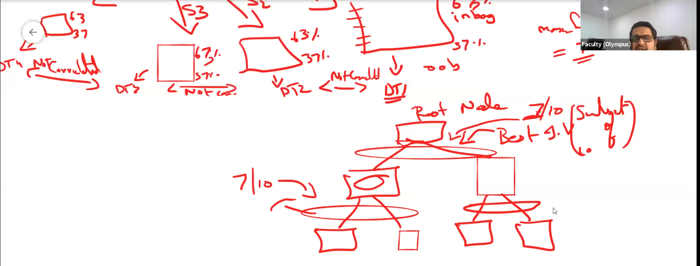

Why do we need to have max features and random sampling?

There are two objectives behind that –

1. We want the individual decision trees to be strong in their individual capacity
2. Each decision tree has to be independent of other decision trees i.e., I would want the correlation to be less between the trees

**Using GridSearch we can identify the optimal value of max features**

**Note :** The variety is what makes random forests more effective than individual decision trees

**OOB Score** – This is the method of finding the accuracy of a random forest which in one way sets it apart from decision tree.

Now, in DT we were finding the accuracy of our model by applying the test data on the model.

But in the case of random forest as we are using bootstrapped dataset as input of various decision trees, there are some records or samples which are termed as “Out-of-bag”. Specifically, they are 37%. These out-of-bag samples are unknown to their respective decision trees. We will input them and predict their output. This output for each record/sample will be taken for each respective decision tree

OOB score is the proportion of the out-of-bag classes correctly identified by the decision trees.

**Important links:**

1. <https://towardsdatascience.com/understanding-random-forest-58381e0602d2>
2. <https://towardsdatascience.com/what-is-out-of-bag-oob-score-in-random-forest-a7fa23d710>
3. <https://neptune.ai/blog/random-forest-regression-when-does-it-fail-and-why>

# **KNN ML Model**:

Types of distance understood. Read [this](https://medium.com/@kunal_gohrani/different-types-of-distance-metrics-used-in-machine-learning-e9928c5e26c7#:~:text=Hamming%20distance%20is%20used%20to,similarity%20between%20two%20data%20points.) article.

1. Euclidean Distance:



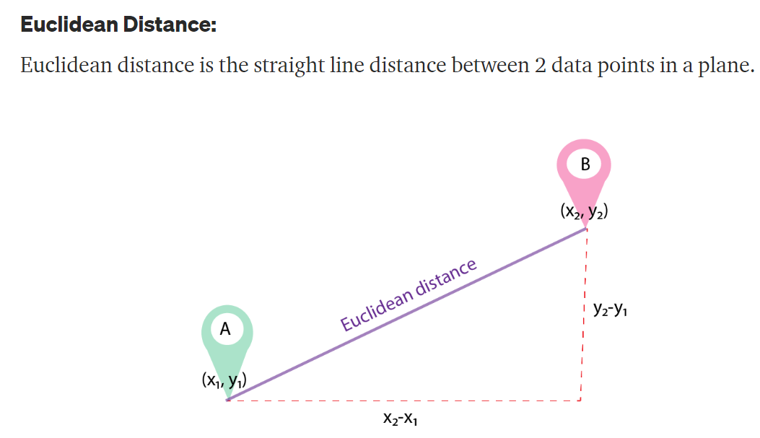

1. Manhattan Distance:



Manhattan distance is computationally inexpensive distance to calculate. Therefore, in cases of High dimensionality data, we prefer to use Manhattan distance as the metric.

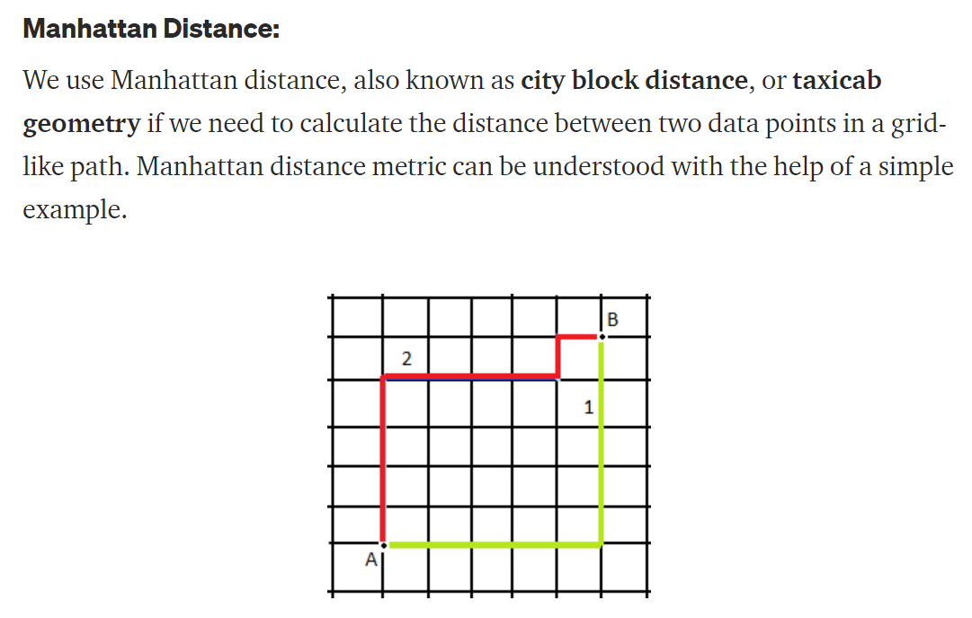

1. Minkowski Distance: It is the generalized version of distances like Manhattan, Euclidean, and Chebyshev. In the K Neighbors classifier, we use Minkowski distance.

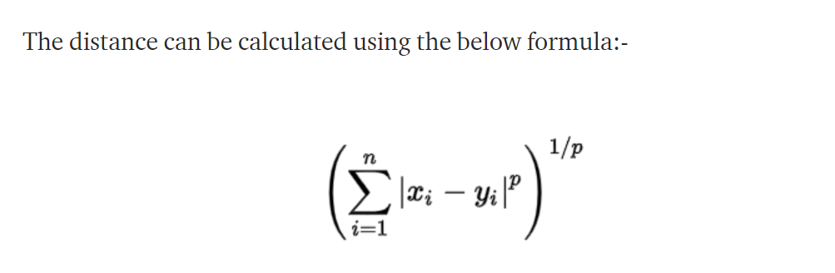

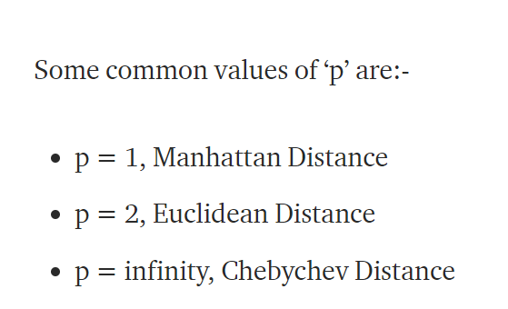

1. Cosine distance and Cosine similarity**:** 
   * + This distance is primarily used to assess the degree of similarity between data points.
     + This distance can be used in recommender systems

Cosine similarity: Cos(X). X is the angle between the data vectors. If X is 90 degrees. The similarity will be 0 and the cosine distance (1- Cos(X)) will be 1.

Therefore, the distance will be maximum when the similarity is minimum (or in other words data points are completely different from one another).

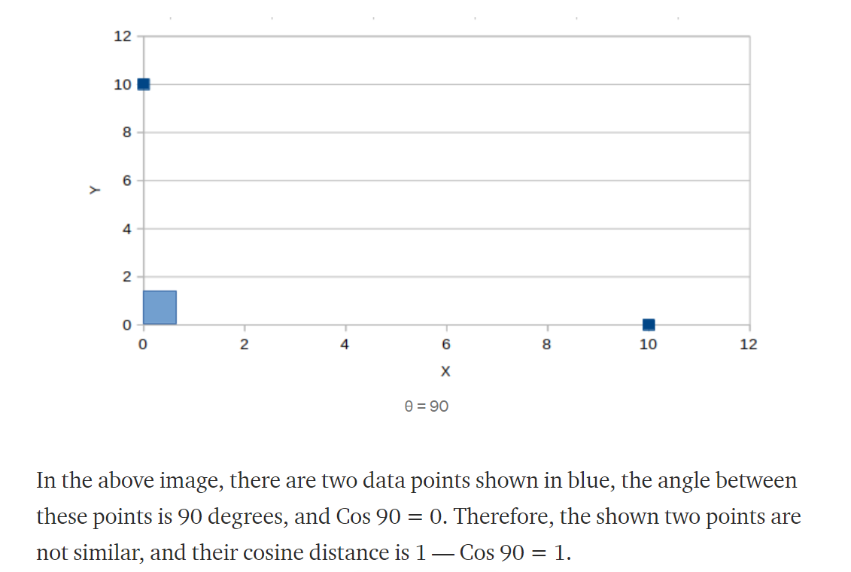

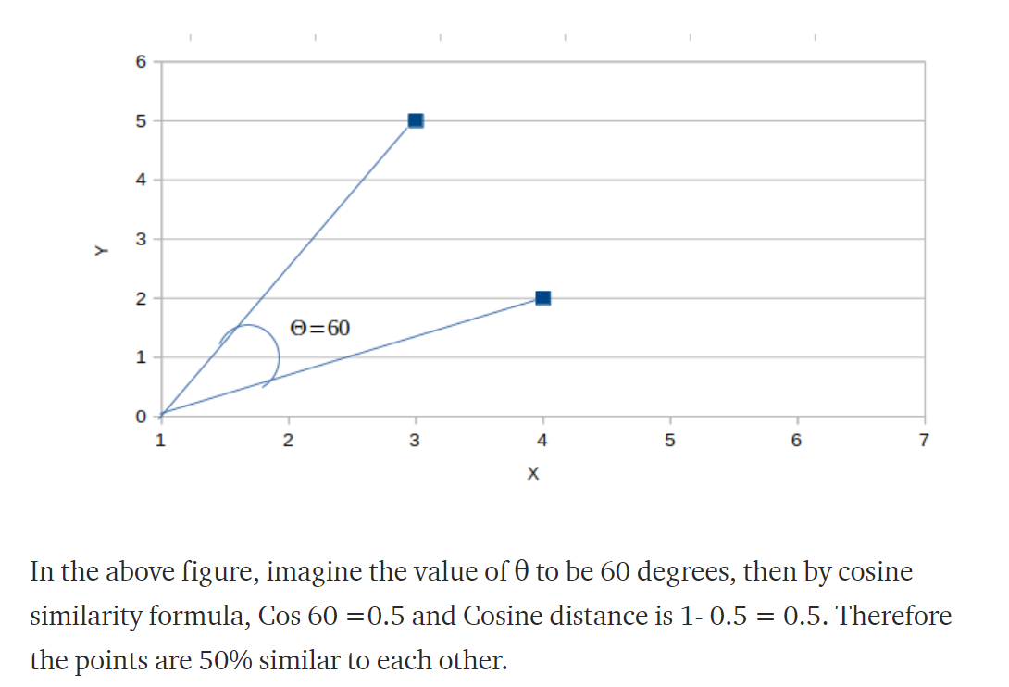

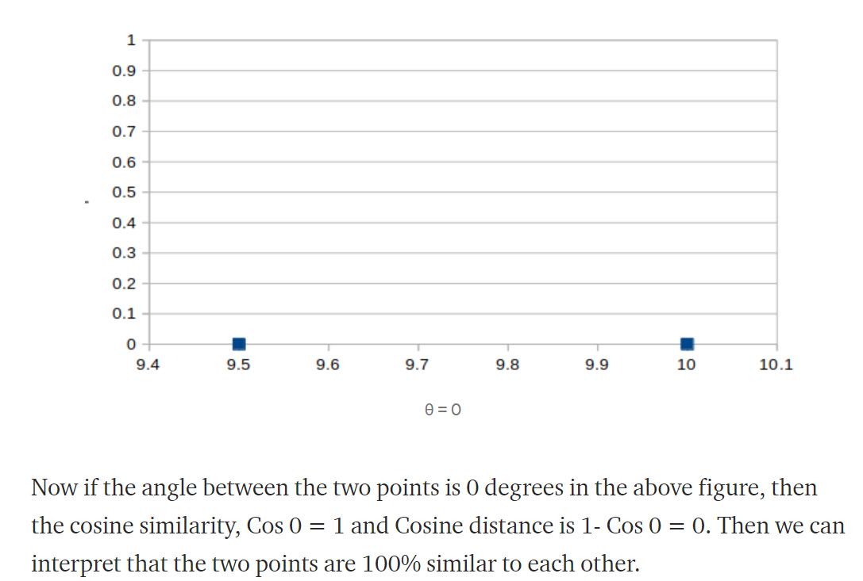

Distance metric for categorical variables:

Hamming distance:

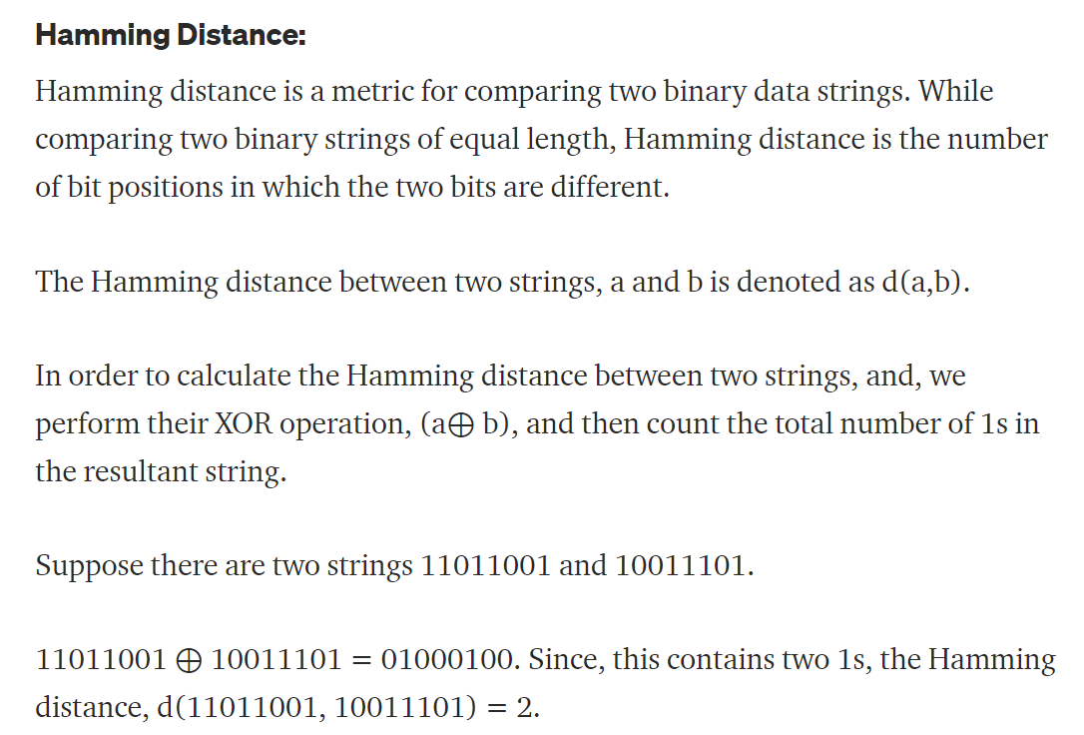

# K -> No. of neighbours

# NN -> Nearest Neighbours

KNN model is a lazy learner.

**Scaling of Data**:

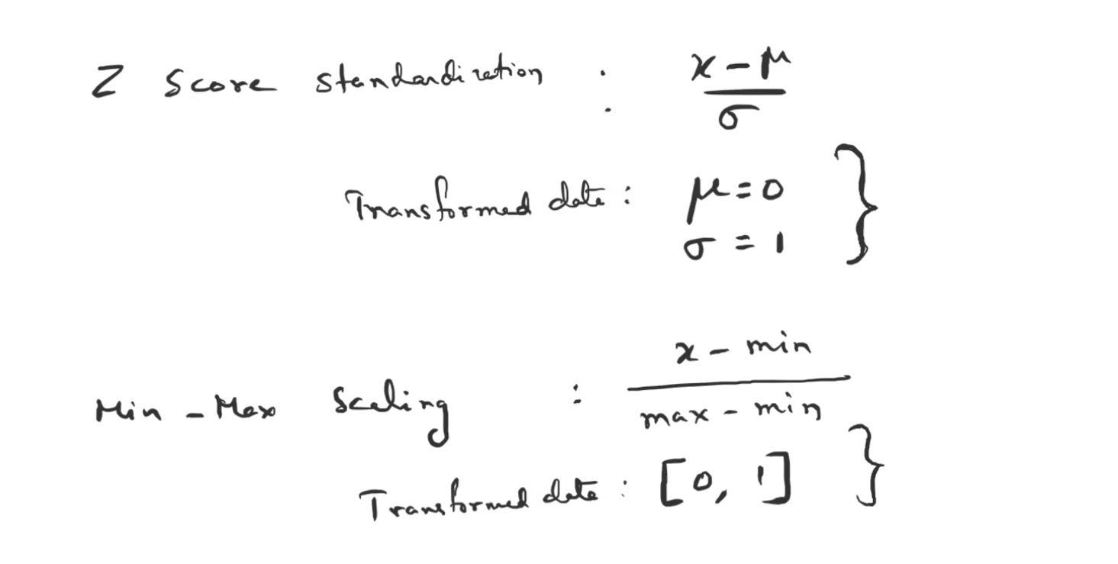

* It is not recommended to use it for multi-class classification

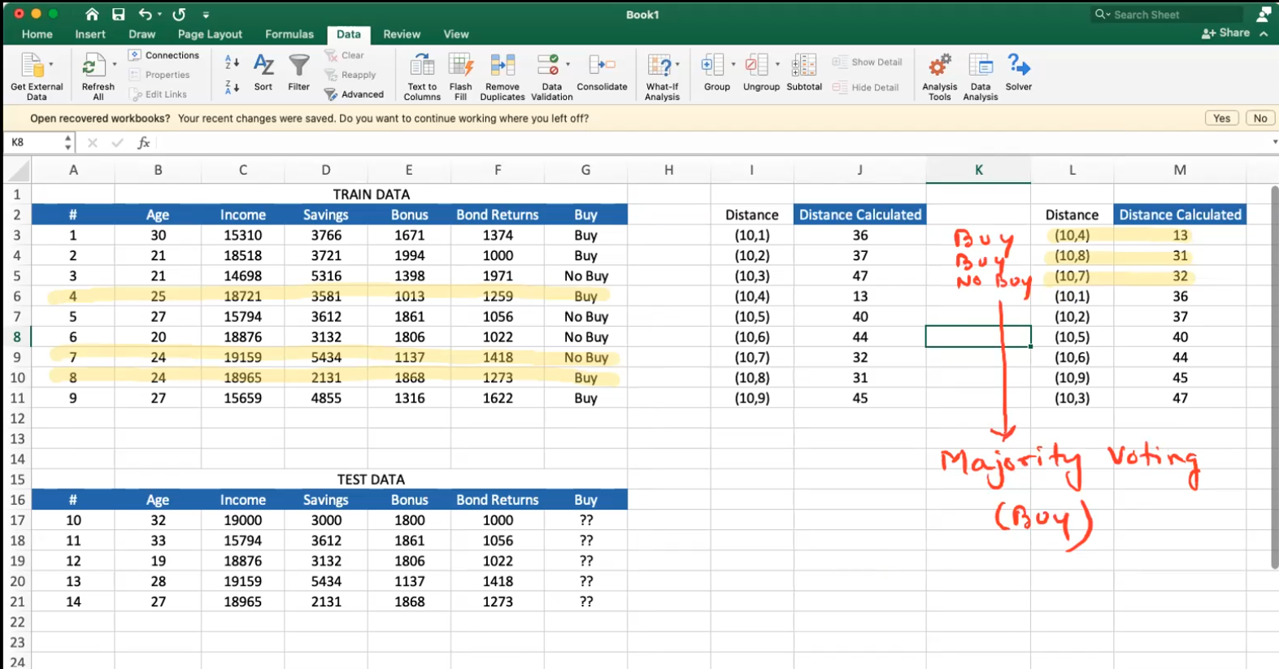

# **How does KNN work?** – KNN is a non-parametric algorithm which means that it doesn’t care about the distribution of your data

* KNN first computes the distance between each of the observations and the observation in question and then sort out the distance in ascending order
* Now, it finds out the top K distances from my observation in question and find out the value of the dependent variable for each of those top K observations and majority of those labels is assigned to my dependent variable

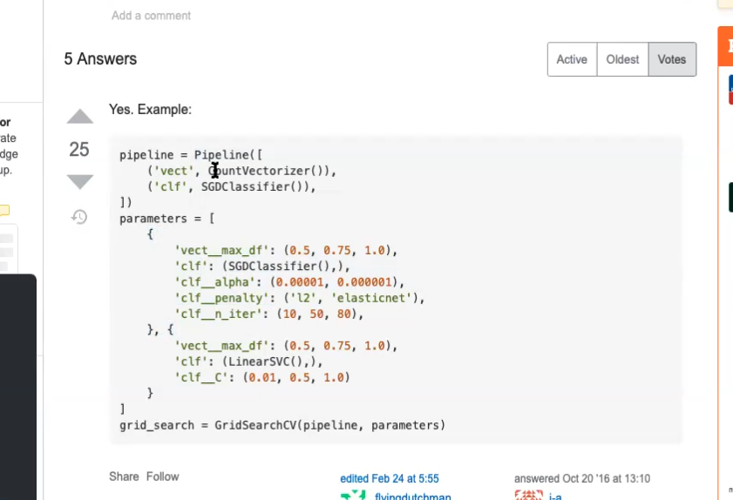

# **Encoding of categorical features:**

There are many ways to convert categorical features into numerical data. Some of them are:

1. Label Encoding: This chooses an arbitrary number for each of the category. **This is useless!**
2. Ordinal encoding: In this method, we replace each of the categories by a number according to the order
3. One-hot encoding: This can make the situation complex if there are many categories
4. Count/Frequency encoding: In this method we replace the category by their respective frequencies/count
5. Target encoding: Each of the categories of the feature is replaced by the average value of the target for that particular category. In case, the count of one feature is very less, this method can then lead to overfitting. Target encoding is applied when the cardinality (i.e., number of unique features are high)

Therefore, to avoid overfitting, we use Smoothing method.

**Method #1** to apply target encoding

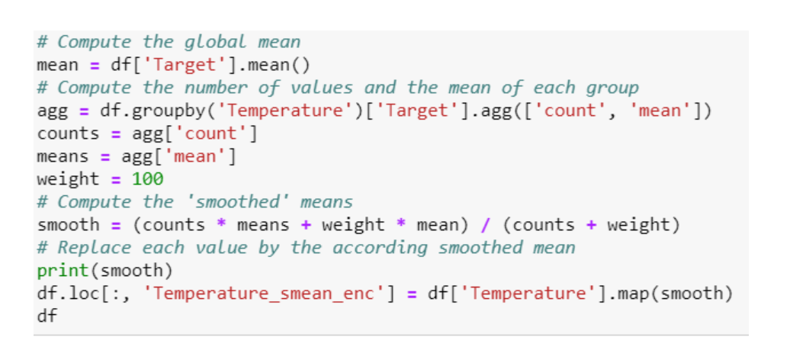

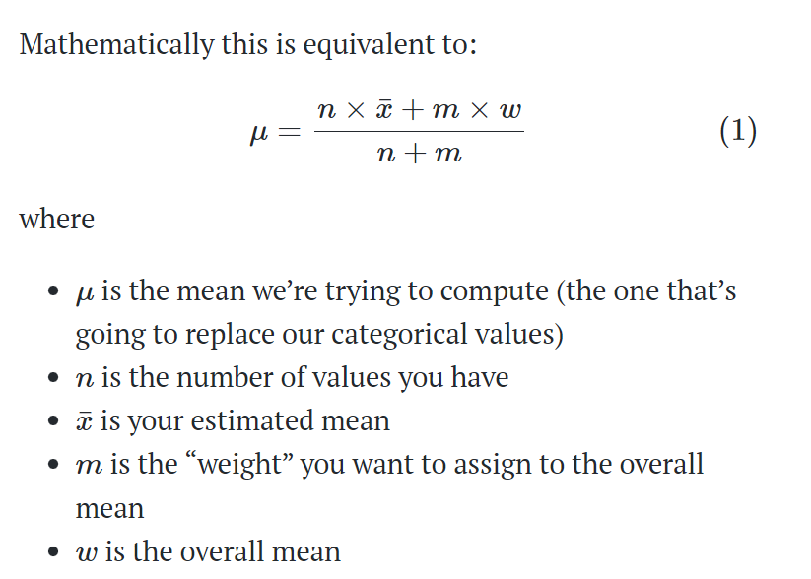

Here ‘m’ can be any integer.

**Method #2** – Of applying Target encoding. Remaining code is present in the Jupyter note book

* We will have to create a separate dataset out of our train dataset to train the encoder.

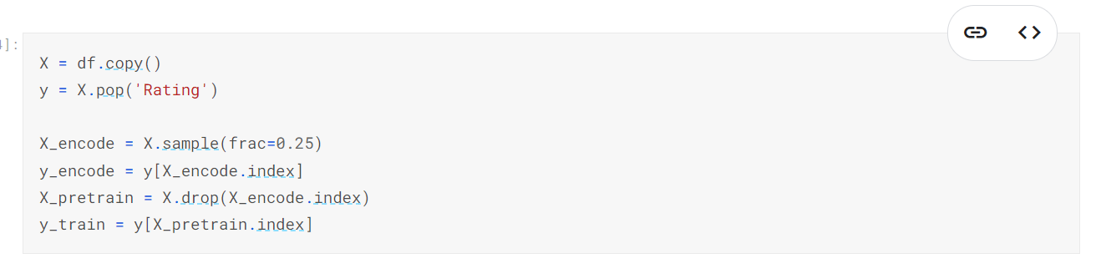

# **Naïve Bayes Classifier**:

Naïve Bayes classifier is a supervised ML algorithm used for classification tasks.

The key difference is that naive bayes assumes that features are independent of each other and there is no correlation between features. However, this is not the case in real life. This naive assumption of features being uncorrelated is the reason why this algorithm is called “naive”.

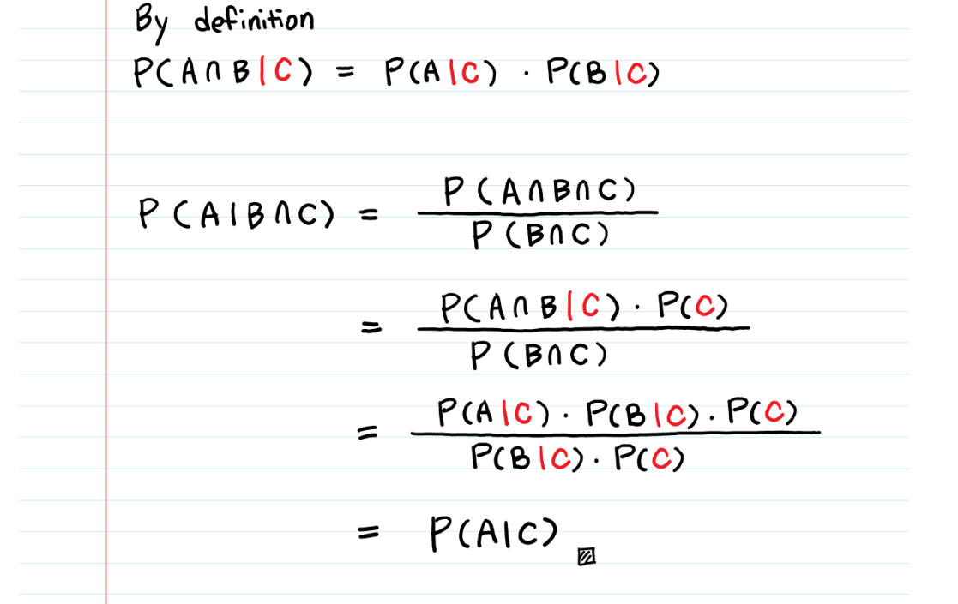

# **Variations of Naïve Bayes**:

1. Gaussian NB – For Continuous Variables
2. Multinomial NB – Integer based independent variables. Useful for text-based models
3. Complement NB – For imbalanced dataset
4. Bernoulli’s NB – For binary independent variables
5. Cat NB – For categorical independent variables

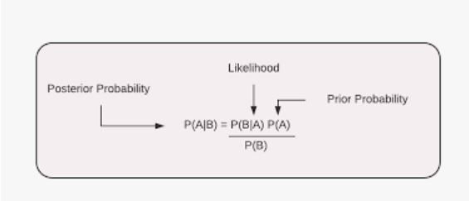

*1. Assume the data to be independent to each other.*

*2. Fit the continuous data to Gaussian NB. And get the probability/Log probability of occurring of this continuous data.*

*3. Fit the categorical data to Categorical NB. And get the probability/Log probability of occurring of this Categorical data.*

*4. Let’s get the log probabilities for steps (2) and (3). Let them be****Log_Proba_Cont****and****Log_Proba_Cat****.*

*5.****Log_Proba_Cont and Log_Proba_Cat uses Prior probability of Label in their calculation. Hence we will subtract it once while adding both the probabilities****.*

*6. i.e Final log probability of the entire dataset can be***Log_Proba_Cont + Log_Proba_Cat —P(L)**

*7.****This is equivalent to proba(cont) * proba(cat) / prior(Label)****. Log of the probas in line (6) converts multiplication to addition.*

Text data can be converted into quantitative data for doing the analysis on it. There are two approaches primarily to do so.

1. Bag-of-words
2. Word2vec

**Approach of converting the text data into quantitative data**

**Step #1 –** A matrix called as document-term-matrix (DTM) is generated. It is a matrix which has number of rows equalling to the number of text messages or line items in the text data. But the columns are generated in a different manner such that every unique word is a column in itself and a matrix is generated

**Step #2 –** Every unique word creates one column of the DTM and every row is generated in a manner such that it counts the number of occurrences for a word. For e.g., say I had a word ‘Go’. I will count the occurrence of word Go in message #1 and fill the cell (1,1) by its count of occurrence in message #1. Similarly, every word is counted. This process is called as CountVectorization. “Wherever there is a space it is taken as a new word”.

**Note –** Sparse matrix is a matrix which has most of its elements zero. There is a much better method of representing a sparse matrix as mentioned below. It helps to save space.

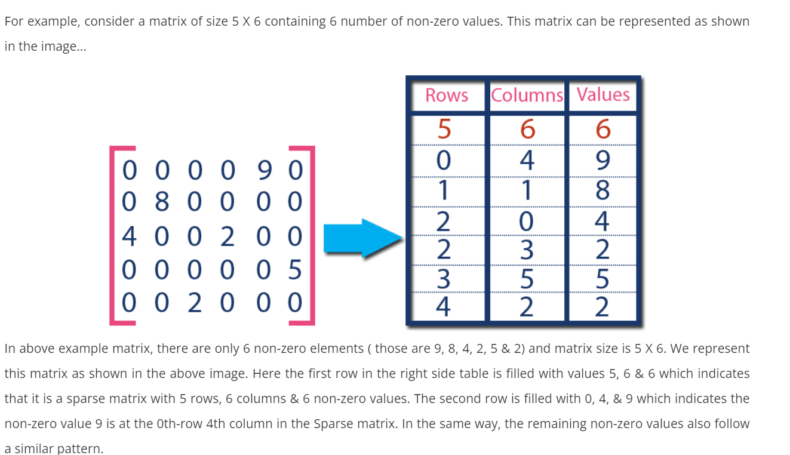

# **Bias and Variance**:

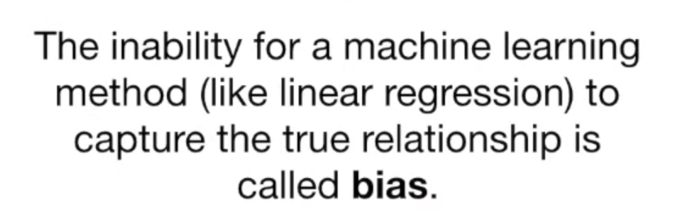

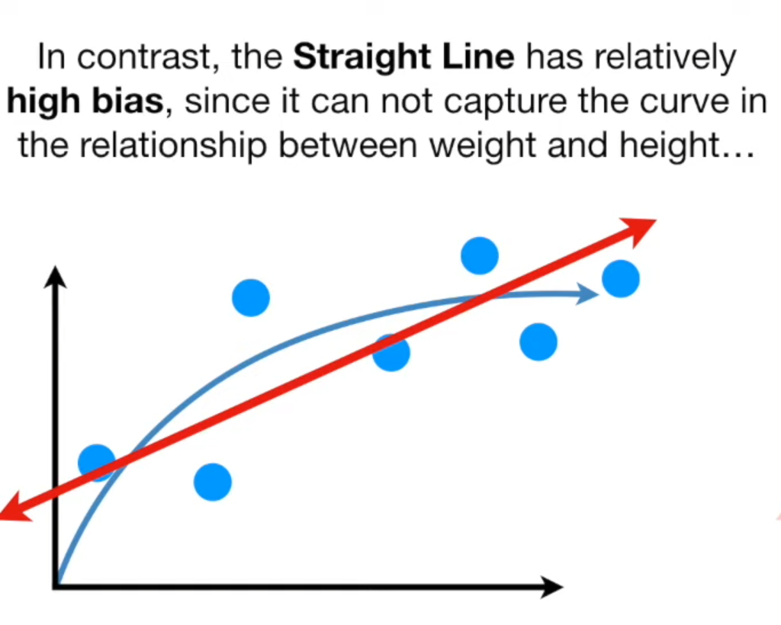

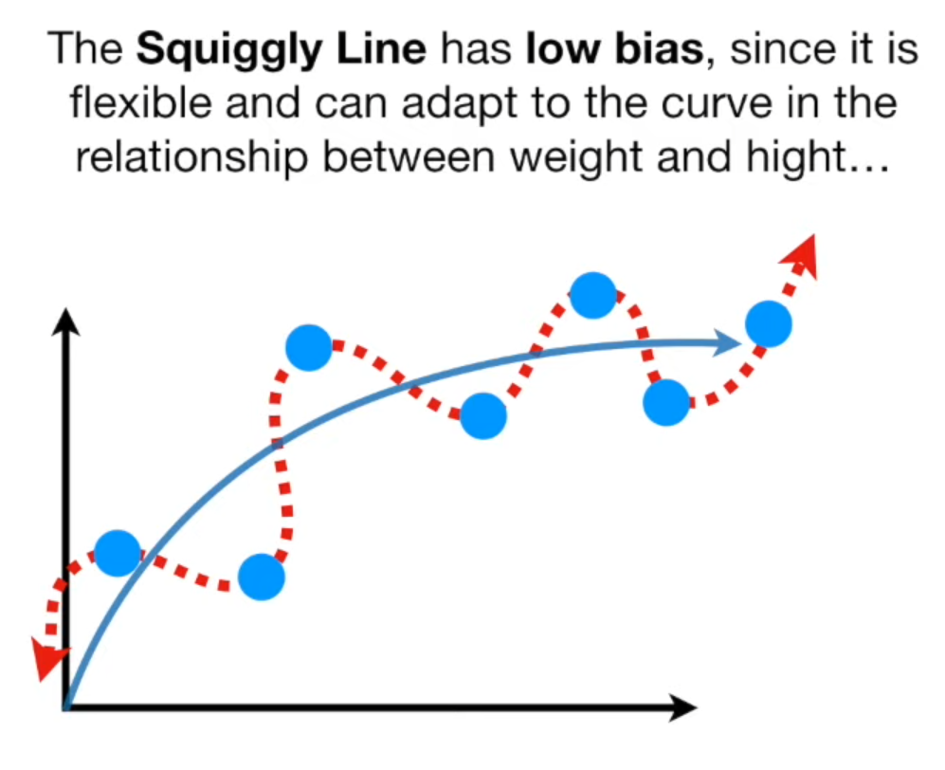

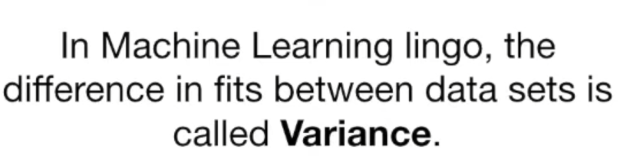

# **Ensemble Methods**

There are 4 types of Ensemble techniques:

1. Bagging (Bootstrap aggregation is abbreviated as Bagging)
2. Boosting
3. Stacking
4. Cascading

**Adaboost:** It is called as Adaptive Boosting. It involves using decision trees as its fundamental elements.

For any boosting model, there are three fundamental differences in the working of boosting model when compared with Bagging. These are:

* Weak learner: In the case of Bagging (say random forest), we prefer to have each contributor as a fully grown decision tree. But in the case of Boosting, we have what is known as weak learners (a decision tree with depth 1) i.e., they are not well trained on the training data. These decision trees (in the case of AdaBoost) are a decision trees with one root node and two leaf nodes. These are called **stumps**. Therefore, in the case of boosting our contributors are high bias and low variance type but in the case of bagging the contributors are low bias and high variance
* Weight: In the case of Bagging, each contributor had equal say in terms of determining the output but in the case of boosting. There is a weightage to each of the contributors making one contributor having more say in determining the output than the other.
* Dependency: In the case of bagging, each contributor was independent of each other in fact, we deliberately created them in a way such that they are uncorrelated but in the case of boosting each of the contributor is dependent on one another as their input is the output of the other contributor

**Steps of Adaboost:**

**Step #1 –** Weights are assigned to each record. Initially, one common weight is assigned to every record

**Step #2 –** Choosing the best decision stumps. Each weak learner takes one column and is trained on the training data and whichever stump is able to separate the data in the best form on the basis of Entropy or Gini index will be chosen as the best decision stump

**Step #3 –** Calculating the weight. In bagging every contributor had equal say in the final decision of the model and hence we followed what majority had to say. But in the case of boosting, we will calculate the weights. We are doing that in this step.

AdaBoost algorithms can be used for both classification and regression problem

Scaling is not necessary.

# **Gradient Boosting:**

* This performs much better than AdaBoost
* This can be used for regression as well as classification
* The fundamental concept of Gradient Boosting is having multiple learners and each learner learning from the mistakes made by the previous learner
* Generally, the learners in boosting are decision trees as they have been able to provide
* Learning rate is added in the step #3 below to prevent overfitting. It can be described as moving towards the correct value in small steps.

**Gradient Boosting for a regression problem**:

**Step #1 –** First learner spits out the mean value of the target column for each record fed into it. For e.g., If in my training data the mean of the target column is 3.5 then if I feed any data to my first learner, it will predict 3.5 for every record.

**Step #2** – Then model 2 is created to predict the errors made by the model 1. For this model, the input will be the same as it was for model 1 but its output will be residuals of the predictions by model 1

**Step #3 –** Final prediction is done by adding

M1 + (learning rate*M2).

**Step #4 –** Repeat step #2 for another model.

# **Regularization**:

Regularization will help us to reduce overfitting in a model.

There are three types of regularization:

1. Ridge (L2) - <https://towardsdatascience.com/ridge-regression-for-better-usage-2f19b3a202db>
2. Lasso (L1)
3. Elastic net

In regularization, the idea is to prevent overfitting an increase the generalizing power of the model. In linear regression, overfitting caused by the **inflation of coefficients**.

1. Wherever there is a presence of Linear Equation/Regression, we can make use of the L1 & L2 regularization. For e.g., Linear Regression, Logistic Regression, Neural Networks, etc.
2. Any model can make two kinds of errors:

* Bias: This is called as model’s inability to capture the true relationship between dependent and independent variables. This can be determined by train accuracy
* Variance: Difference between training and test accuracy should not be more than 5% - 10%

1. If the model’s accuracy is low say around 60, 65, or 70% then, we categorize that model with low bias
2. We do not have much of a control over bias but variance can be taken care of using regularization
3. There is a trade-off between bias and variance
4. Low bias and low variance is the ideal situation that we’d like to have

**Regularization in Linear regression:**

* In linear regression, overfitting is caused by inflation of coefficients.
* To deflate the coefficients, we make use of regularization
* L1 called as Lasso and L2 called as Ridge

**Intuition behind Regularization:** Smaller the coefficients, simpler the model and hence we can avoid overfitting.

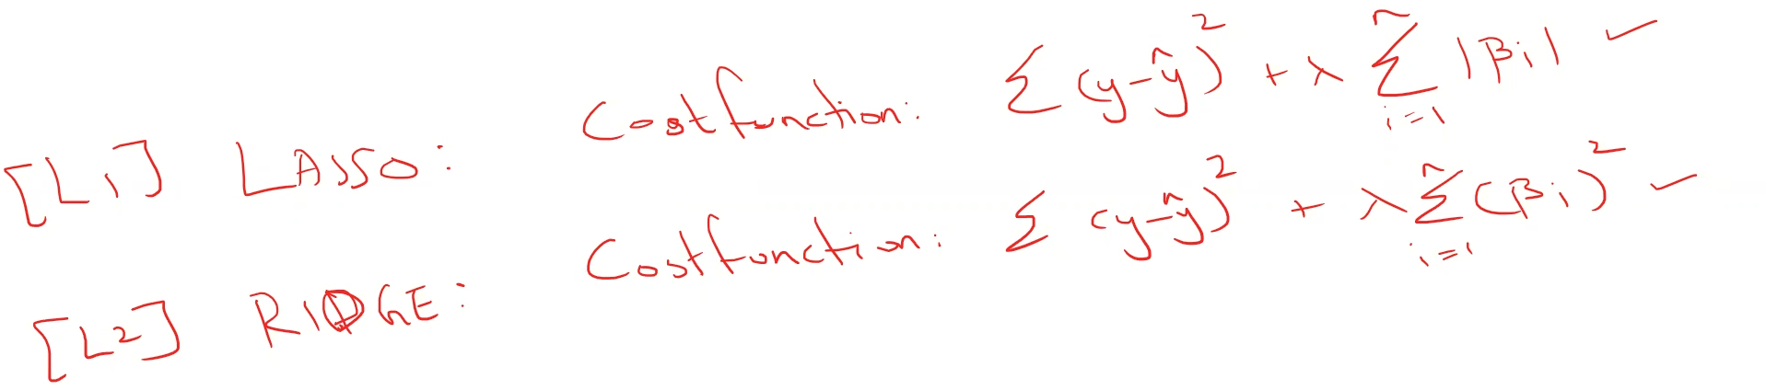

* ƛ is called as learning rate
* **Ridge regression** reduces multicollinearity
* It only shrinks the coefficients but doesn’t make it zero
* **Lasso regression** shrinks the coefficients of the variables to zero if that variable is not useful. It stands for Least absolute shrinkage and selection operator (LASSO).
* In both the cases of regularization, the cost function is to be minimized. The way it is done is:

**L1 Regularization: Lasso Regression -** In this case, I have two terms to minimize. (1) SSE and (2) The penalty term, which is the absolute sum of the coefficients. In order to minimize the penalty term, we will have to make some coefficients zero. The way it is done is that the coefficients of the variables which are not significant will be made zero.

Lasso regression can be used as a feature selection technique

**L2 Regularization: Ridge Regression -** In this case again, I have two terms to minimize. (1) SSE and (2) The penalty term, which is the sum of the squared values of the coefficients. In order to minimize the penalty term, we will have to bring this term as much as possible to zero. The way it is done is that the coefficients of the variables will be shrunken and so much so that they are very close to zero but **not equal to zero.**

Ridge regression can be used to reduce multicollinearity

* ƛ is a GridSearch problem
* **Scaling is not required in the linear regression problems alone but while using regularization, it is advised to scale the data.**
* **Cost function is MSE**

**Motivation for Ridge and Lasso regression**:

* When selecting the

# **Gradient Descent**: Gradient descent is an algorithm in which any function (must be differentiable) can be fed and it will output the minima of that function.

Gradient points in the “***direction of greatest ascent***” and the length of the vector is the “***steepness of the ascent***”

f(x,y) = x2 + y2. The vector with partial derivatives of f(x,y) w.r.t to x and w.r.t to y will give you the gradient of the function.

When we want to minimize a multivariable function, we tend to look for the input points where this function is at its local minimum. Gradient descent is the technique that allows us to do that. We take small steps in the direction of steepest decrease iteratively until the difference between xnew and xold is very small like 0.0001 because at that point it would mean the slope is almost 0.

Equation is:

Xnew = Xold – (learning_rate*slope)

* Slope is the partial derivative of the cost function w.r.t X

Slope is the gradient in this equation.

For more than one feature:

Ynew = Yold – (learning_rate*slope)

* Slope is the partial derivative of the cost function w.r.t Y

**Boosting:**  Boosting is an ML technique in which multiple weak learners (models which have low bias i.e., which are shallow sometimes may be stumps which have just 1 depth and only 2 leaf nodes) are sequentially combined to perform classification (applicable for binary and multiclass) or regression such that every learner works to reduce the errors made by preceding model.

All the base models are decision trees in Gradient boosting whereas in AdaBoost the base model can be anything.

**Step #1**: Model #1 will give us the mean value of the target variable for every observation.

**Step #2:** Model #2 will be fitted to the residuals(or errors) of model #1. Using gradient descent, I will minimize the loss function of this model.

Thus far, the prediction will be m1(output of model #1) + lambda*m2(output of model #2)

Here lambda is the learning rate.

One key point to be noted, on each stage, the prediction is



The tree made on residuals is the prediction of the residuals made by each tree.

# **XGBoost**: (This can be used for regression, binary classification, and multi class classification). XGBoost employs CART. CART is a binary decision tree that divides a node into two leaf nodes repeatedly

Imagine that you are a hiring manager interviewing several candidates with excellent qualifications. Each step of the evolution of tree-based algorithms can be viewed as a version of the interview process.

1. **Decision Tree**: Every hiring manager has a set of criteria such as education level, number of years of experience, interview performance. A decision tree is analogous to a hiring manager interviewing candidates based on his or her own criteria.
2. **Bagging**: Now imagine instead of a single interviewer, now there is an interview panel where each interviewer has a vote. Bagging or bootstrap aggregating involves combining inputs from all interviewers for the final decision through a democratic voting process.
3. **Random Forest**: It is a bagging-based algorithm with a key difference wherein only a subset of features is selected at random. In other words, every interviewer will only test the interviewee on certain randomly selected qualifications (e.g. a technical interview for testing programming skills and a behavioural interview for evaluating non-technical skills).
4. **Boosting**: This is an alternative approach where each interviewer alters the evaluation criteria based on feedback from the previous interviewer. This ‘boosts’ the efficiency of the interview process by deploying a more dynamic evaluation process.
5. **Gradient Boosting**: A special case of boosting where errors are minimized by gradient descent algorithm e.g. the strategy consulting firms leverage by using case interviews to weed out less qualified candidates.
6. **XGBoost**: Think of XGBoost as gradient boosting on ‘steroids’ (well it is called ‘Extreme Gradient Boosting’ for a reason!). It is a perfect combination of software and hardware optimization techniques to yield superior results using less computing resources in the shortest amount of time.

**Hyperparameter Tuning in XGBoost**: [Detailed article](https://www.analyticsvidhya.com/blog/2016/03/complete-guide-parameter-tuning-xgboost-with-codes-python/)

There are three kinds of parameters in XGBoost. : [Documentation](https://xgboost.readthedocs.io/en/stable/python/python_api.html)

1. **General Parameters**: Guide the overall functioning
2. **Booster Parameters**: Guide the individual booster (tree/regression) at each step
3. **Learning Task Parameters**: Guide the optimization performed

### **Step 1: Fix learning rate and number of estimators for tuning tree-based parameters**

### **Step 2: Tune max_depth and min_child_weight**

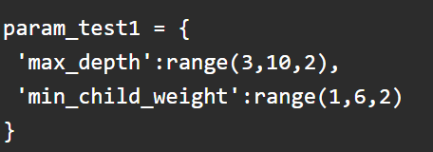

Run the gridsearch on these parameters and look for the highest score. You will find ideal values are 5 for max_depth and 5 for min_child_weight.

Tuning the max_depth and min_child_weight further by reducing the interval.

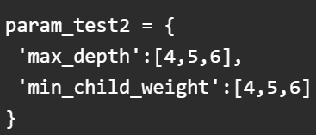

Here, we get the optimum values as 4 for max_depth and 6 for min_child_weight

### **Step 3: Tune gamma**

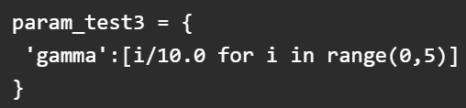

### **Step 4: Tune subsample and colsample_bytree**

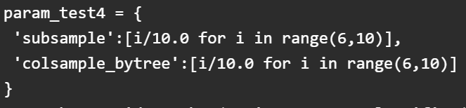

Filtering these values down

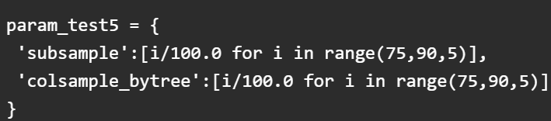

### **Step 5: Tuning Regularization Parameters**

**Notes:**

1. n_jobs: When you use n_jobs = -1, the load which is created while fitting the model or performing any task is shared by all the processors in your machine. This way of sharing load is called Parallelism. It also takes lesser time than compared to performing tasks without using Parallelism.
2. scale_pos_weight[default=1]:

* It controls the balance of positive and negative weights,
* It is useful for imbalanced classes.
* A value greater than 0 should be used in case of high class imbalance as it helps in faster convergence.
* A typical value to consider: sum(negative instances) / sum(positive instances).

1. silent:

* Silent mode activated is set to 1, i.e. no running messages will be printed.
* It’s generally good to keep it 0 as the messages might help in understanding the model.

1. eta: Analogous to learning rate in GBM. **Typical values in 0.01-0.2**
2. min_child_weight:[default=1]. Higher values prevent a model from overfitting and too high values can lead to underfitting. **Grid search should be used here**.
3. max_depth: Typical values [3-10]. Should be tuned using CV.
4. subsample: **Typical values: 0.5-1**
5. colsample_bytree: **Typical values: 0.5-1**
6. **missing = np.NaN:** If I input missing parameter as np.NaN then it will consider any value which np.NaN as a missing value
7. **gamma = [0,0.5]**
8. **reg_alpha: Lasso parameter Typically 0**
9. **reg_lambda: ridge parameter Typically 0**

**Learning task parameters:**

1. objective: This defines the loss function to be minimized.

* [default=reg:linear]
* binary:logistic –logistic regression for binary classification, returns predicted probability (not class)
* multi:softmax –multiclass classification using the softmax objective, returns predicted class (not probabilities)

you also need to set an additional num_class (number of classes) parameter defining the number of unique classes

* multi:softprob –same as softmax, but returns predicted probability of each data point belonging to each class.

1. **eval_metric [ default according to objective ]**
   1. The metric to be used for validation data.
   2. The default values are rmse for regression and error for classification.
   3. Typical values are:
      1. **rmse** – root mean square error
      2. **mae** – mean absolute error
      3. **logloss** – negative log-likelihood
      4. **error** – Binary classification error rate (0.5 threshold)
      5. **merror** – Multiclass classification error rate
      6. **mlogloss** – Multiclass logloss
      7. **auc:** Area under the curve

# **Cross-validation techniques:**

1. Hold-out cross validation technique: The regular train and test split itself is called as Hold-out cross validation approach
2. KFold cross validation
3. Stratified K-Fold: Preferred for imbalanced dataset
4. Leave-one-out
5. Leave-p-out: Technique #4 and #5 are rarely used in real world scenario

# **F1, Micro-F1, or Macro-F1 score:**

In the classification report, we have three kinds of values:

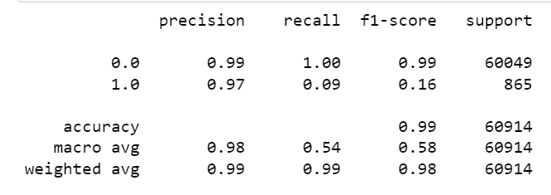

1. Accuracy
2. Macro avg.
3. Weighted avg.

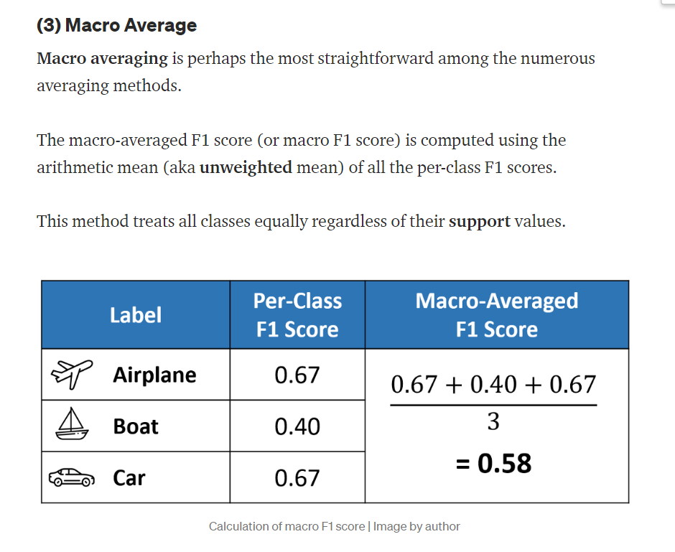

**When to use F1-Macro?**

In general, if you are working with an imbalanced dataset where all classes are equally important, using the macro average would be a good choice as it treats all classes equally.

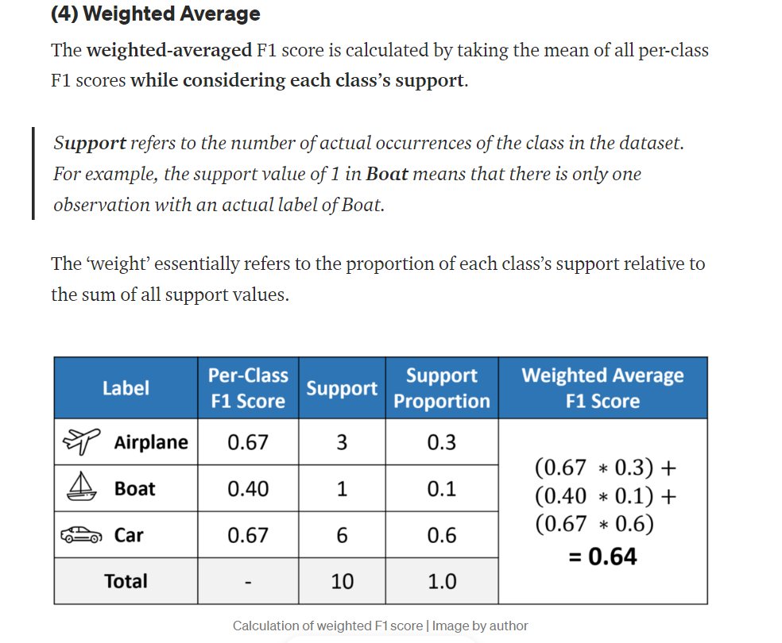

**When to use weighted F1-score?**

If you have an imbalanced dataset but want to assign greater contribution to classes with more examples in the dataset, then the weighted average is preferred.

This is because, in weighted averaging, the contribution of each class to the F1 average is weighted by its size.

**When to use accuracy/f1_mcirco?**

Suppose you have a balanced dataset and want an easily understandable metric for overall performance regardless of the class. In that case, you can go with accuracy, which is essentially our micro F1 score.

# **LightGBM**:

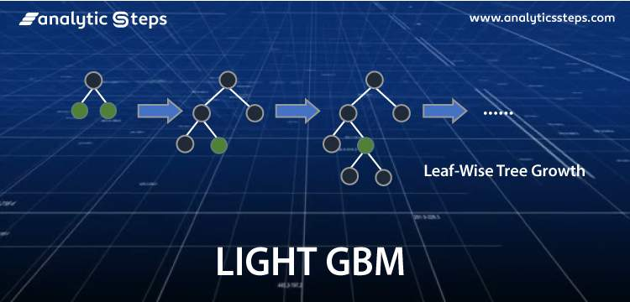

LightGBM is called “Light” because of its computation power and giving results faster. It takes less memory to run and is able to deal with large amounts of data. Most widely used algorithm in Hackathons because the motive of the algorithm is to get good accuracy of results and also brace GPU leaning

**When to use LightGBM?**

LightGBM is not for a small volume of datasets. It can easily overfit small data due to its sensitivity. It can be used for data having more than 10,000+ rows. It is recommended to use LightGBM for datasets with minimum 10000 rows. There is no fixed threshold that helps in deciding the usage of LightGBM. It can be used for large volumes of data especially when one needs to achieve a high accuracy.

1. LightGBM can be used for regression, binary classification, and multi-classification

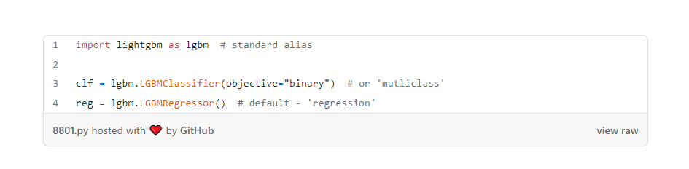

1. If I am choosing a high number of estimators (n_estimators) then I will decrease the learning rate to avoid overfitting.
2. **Early stopping**: Each tree in the ensemble builds on the predictions of the last tree — i.e., each boosting round is an improvement of the last. If the predictions don’t improve after a sequence of rounds, it is sensible to stop the training of the ensemble even if we are not at a hard stop for n_estimators. To achieve this, LGBM provides early_stopping_rounds parameter inside the fit function. For example, setting it to 100 means we stop the training if the predictions have not improved for the last 100 rounds.
3. **Categorical_feature support**: It is better to not One-hot encode categorical features for LightGBM. This can take list of strings or int as input which can be

* List of categorical feature names
* List of indices of categorical features

It is needed to convert these categorical features into pandas category data types.

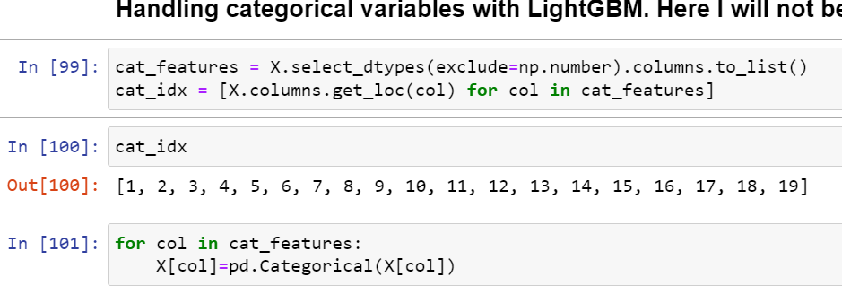

***Note:*** Performance was better when the categorical features were not one hot encoded.

1. How to perform cross-validation?

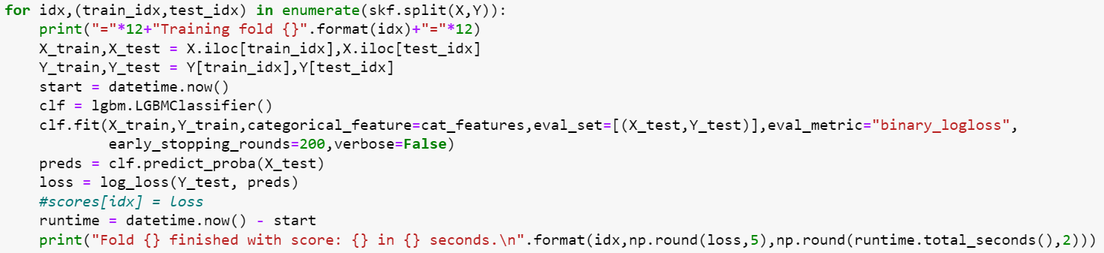

# **Optuna:**

Optuna is a next-generation automatic hyperparameter tuning framework written completely in Python.

**A basic example with Optuna**

Create an objective function that returns the function we want to optimize.

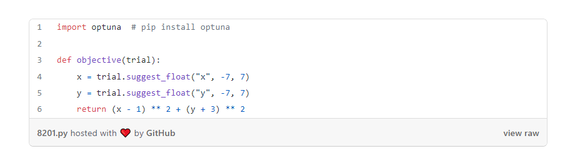

The argument trial is a special Trial object of optuna, which does the optimization for each hyperparameter.

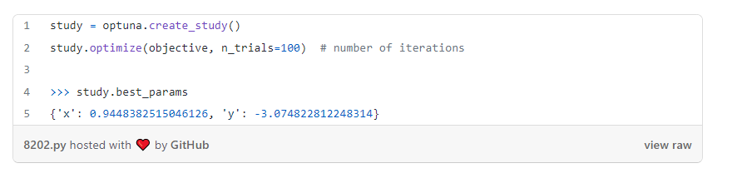

**Magic of optuna:** We can resume the optimization even after it is finished if we are not satisfied with the results! This is a distinct advantage over other similar tools because after the search is done, they completely forget the history of previous trials. Optuna does not!

To continue searching, call optimize again with the desired params. Here, we will run 100 more trials:

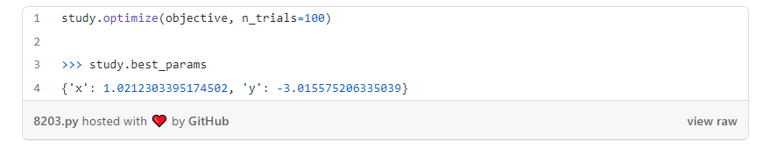

Note that the parameters are closer to the actual minima.

**Defining the Optuna framework:**

In Optuna, the whole optimization process is called a study. For example, tuning XGBoost parameters with a log loss as a metric is one study:

**Step #1:**

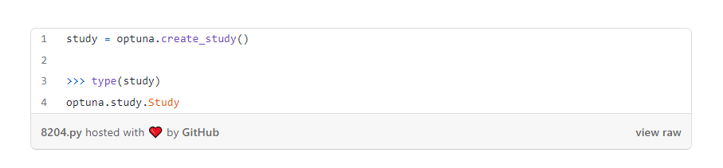

**Step #2:**

A study needs a function it can optimize. Typically, this function is defined by the user, should be named objective and expected to have this signature:

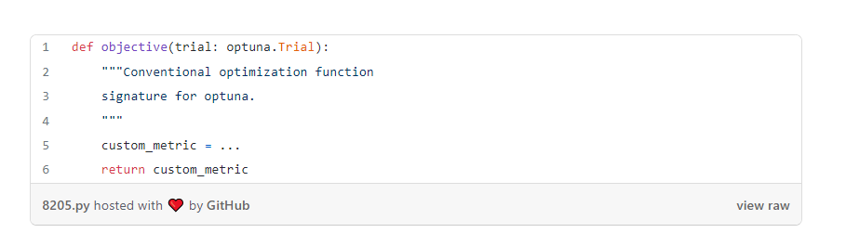

It should accept an optuna.Trial object as a parameter and return the metric we want to optimize for.

As we saw in the first example, a study is a collection of trials wherein each trial, we evaluate the objective function using a single set of hyperparameters from the given search space.

Each trial in the study is represented as optuna.Trial class. This class is key to how Optuna finds optimal values for parameters.

**Step #3**:

To start a study, we create a study object with direction:

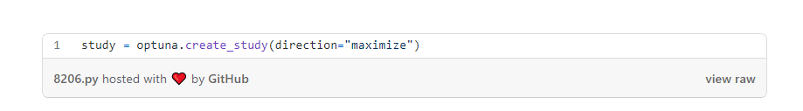

If the metric we want to optimize is a point-performance score like ROC AUC or accuracy, we set the direction to maximize. Otherwise, we minimize a loss function like RMSE, RMSLE, log loss, etc. by setting direction to minimize.

**Step #4:**

Then, we will call the optimize method of the study passing the objective function name and the number of trials we want:

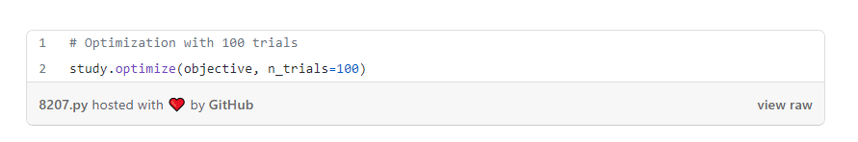

* **suggest_float(name,low,high,step=None,log=False)** - This method takes as input hyperparameter name and it's low and high values as input. It then suggests float values in the range of **[low, high]**. We can specify **step** value if we want to increase the value using that step size. We can also set **log** parameter to **True** to follow a logarithmic pattern in suggesting values. Logarithmic suggestion slowly increases the value of a parameter.
* **suggest_int(name,low,high,step=1,log=False)** - This method works exactly like **suggest_float()** with only difference that it suggests integer values instead.
* **suggest_uniform(name,low,high)** - This method takes parameter name and low & high value of parameter. It then uniformly suggest values of parameter.
* **suggest_categorical(name, choices)** - This method takes as input parameter name and list of different values of that parameter that we want to try. It's generally used for categorical variables of data.

# **Hyperparameter tuning in LightGBM:**

Parameters to tune are:

1. num_leaves: This is the number of leaf nodes in the decision tree. Tuning num_leaves can also be easy once you determine max_depth. There is a simple formula given in LGBM documentation - the maximum limit to num_leaves should be 2^(max_depth). This means the optimal value for num_leaves lies within the range (2^3, 2^12) or (8, 4096). **Keep it between (20,3000)**
2. max_depth: Good enough range is (3-12)
3. learning_rate: Typical values lie within 0.01 and 0.3, but it is possible to go beyond these, especially towards 0.
4. n_estimators.
5. reg_alpha (0,100) : L1
6. reg_lambda (0,100) : L2
7. min_gain_to_split: (0,15) similar to gamma of XGBoost
8. subsample (0,1) : takes a value within (0, 1) and specifies the percentage of training samples to be used to train each tree (exactly like subsample in XGBoost)
9. colsample_bytree (0,1)
10. is_unbalance and scale_pos_weight are the two parameters that can help to deal with imbalanced datasets
11. min_data_in_leaf : (200,10000)
12. min_child_samples : **Important parameter in LightGBM to control overfitting**

When you set Is_unbalace: True, the algorithm will try to Automatically balance the weight of the dominated label (with the pos/neg fraction in train set)

If you want change scale_pos_weight (it is by default 1 which mean assume both positive and negative label are equal) in case of unbalance dataset you can use following formula(based on this issue on lightgbm repository) to set it correctly

**Note:** It is recommended to use n_estimators and learning_rate with early_stopping_rounds. This way you can use many trees

# **Interpretation with XGBoost and LightGBM**

**Interesting reading materials:**

1. <https://towardsdatascience.com/interpretable-machine-learning-with-xgboost-9ec80d148d27>
2. <https://towardsdatascience.com/be-careful-when-interpreting-your-features-importance-in-xgboost-6e16132588e7>
3. <https://towardsdatascience.com/introduction-to-shap-values-and-their-application-in-machine-learning-8003718e6827>
4. <https://slundberg.github.io/shap/notebooks/plots/dependence_plot.html>

**SHAP(SHapley Additive exPlanations):** SHAP can explain any machine learning model without knowing how that model internally works, and it can achieve this using the concepts of game theory

**How to interpret SHAP for Catboost Classifier and Regressor?**

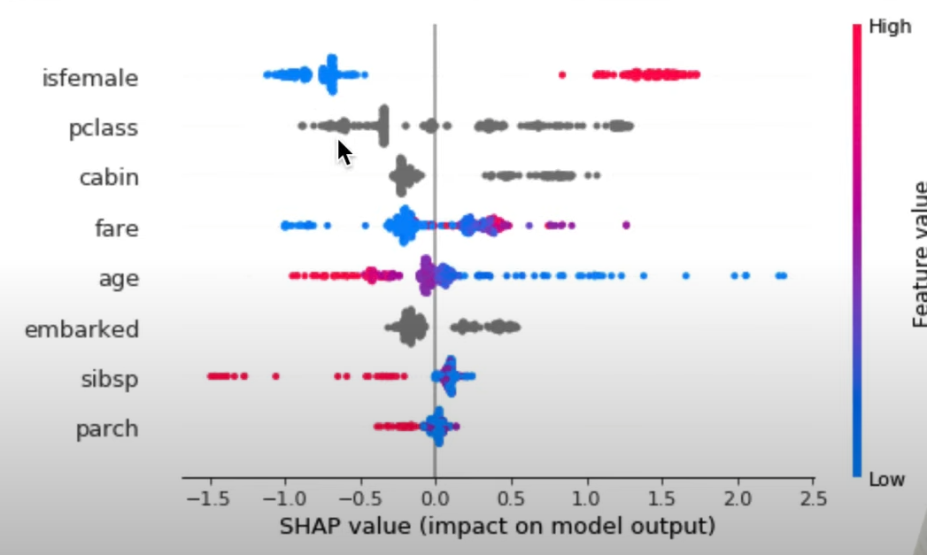

1. This SHAP output is much more friendly with a continuous feature. As seen from the above plot isfemale had (1,0) values. As the value of feature isfemale increases to 1 from 0, the value of model output increases hence it is more probable that the value of model output will be 1 with isfemale value increasing

The higher the SHAP value the higher the probability of survival and vice versa. Moreover, a SHAP value greater than zero leads to an increase in probability, a value less than zero leads to a decrease in probability.

**Detailed code**: <https://github.com/smazzanti/tds_black_box_models_more_explainable/blob/master/Shap2Probas.ipynb>

**Detailed explanation:**

<https://towardsdatascience.com/black-box-models-are-actually-more-explainable-than-a-logistic-regression-f263c22795d>

# **Support Vector Machines:**

1. SVM can be applied to Classification and Regression
2. SVM is robust to outliers
3. It can be applied to non-linear models as well. To do that we use Kernels in SVM.

**Linear data**: If a data can be easily segregated by just drawing a line then that data is called as Linear data

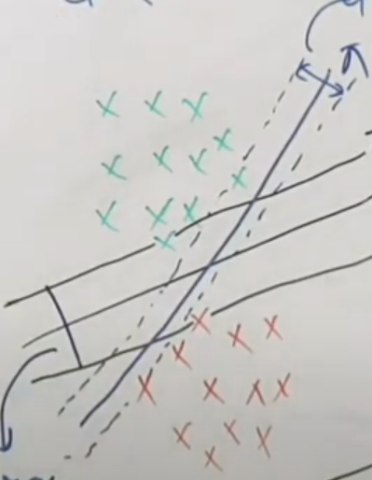

**Non linear data:**  If a data is like the one mentioned in the picture below which can not be segregated using just a line, then it is called as non-linear data.

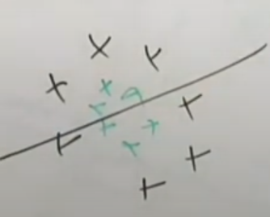

**Motivation behind Hyperplane:** In geometry, a hyperplane is a subspace whose dimension is one less than that of its ambient space. For example, if a space is 3-dimensional then its hyperplanes are the 2-dimensional planes, while if the space is 2-dimensional, its hyperplanes are the 1-dimensional lines

To capture the data in high-dimensionality where there are multiple attributes(features) we would need to have a hyperplane.

Equation of Hyperplane: (This hyperplane is assumed to be passing through 0)

Transpose(W)X=0

### **What are Support Vector Machines (SVMs)?**

SVM is a supervised machine learning algorithm that works on both classification and regression problem statements.

For classification problem statements, it tries to differentiate data points of different classes by finding a hyperplane that maximizes the margin between the classes in the training data. In simple words, SVM tries to choose the hyperplane which separates the data points as widely as possible since this margin maximization improves the model’s accuracy on the test or the unseen data.

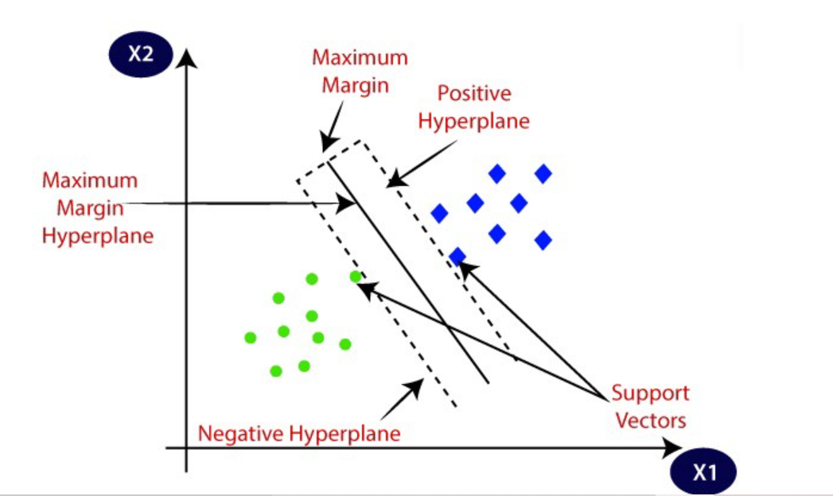

**Decision rule in SVM:**

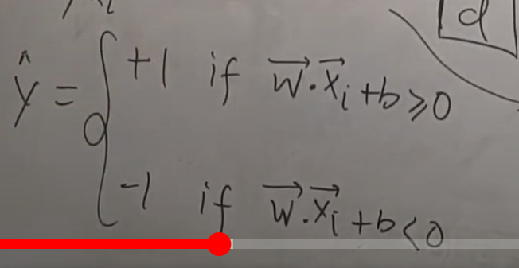

**Cost parameter ‘C’ in SVC class:**

The optimization problem SVM training solves has two terms:

1. A regularization term that benefits "simpler" weights
2. A loss term that makes sure that that the weights classify the training data points correctly.

C is just the balance between the importance of these two terms. If C is higher you're giving a lot of weight to (2), if C is low you're giving a lot of weight to (1).

**If I just want accurate results why don't I just set C really high?**

Term (1) guards against over fitting (being really good at classifying training data but very bad at classifying unseen testing data)

**Ok I just want accurate results why don't I just set C really low then?**

Term (2) makes sure that the training optimization pays attention to the training data, you don't just want "simple" (in the L2 sense) weights, you want simple weights that classify the training data correctly.

SUMMARY:

Training an SVM is a balance of two terms. C is the relative importance of the loss term with respect to the regularization term.

**Hard Margin and Soft margin SVM**: Hard Margin and Soft margin SVMs are the two types of SVM algorithm which are used for two differing purposes. Hard margin SVM is used where the classification labels are well separated from each other and the SVM can find a hyperplane which is able to maximize the margin between the positive hyperplane and negative hyperplane keeping the classes well separated. However, in case the classes are not well separated i.e., some of the labels of one class are present among the labels of other class then soft-margin SVM comes into the picture because hard-margin SVM will not be able to produce a hyperplane in that condition.

**Objective function for Hard Margin SVM:**

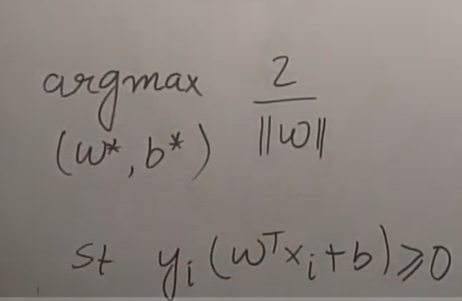

||W|| - This is the magnitude of the vector which is perpendicular to all the three hyperplanes

**Objective function for Soft margin SVM**:

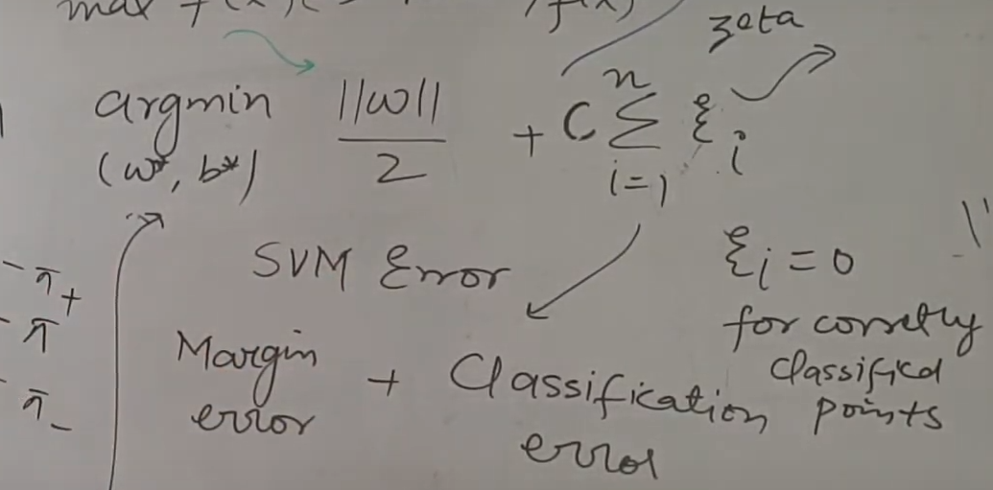

**Hinge loss:** Zeta here is the sum of the distances for the points which are misclassified from their correct plane. For e.g. – A point which was supposed to be classified as 0 was misclassified as 1 then the distance of this point from the negative hyperplane(considering 0 as negative class) will be its distance. We will calculate all that distances and sum them up to produce a term called **“Hinge loss”**.

C.Sum(all the distances) is called as Hinge loss or Classification error

||W||/2 is called as Regularization term or margin error

**C**: This is a hyperparameter.

There are two types of losses in soft margin SVM. One is Margin error i.e., the distance between the hyperplanes and the classification error which measures how not well the classes are classified.

**Note: If I am more rigid about the margin error that is I want to maximize the distance between the hyperplanes and not much care about the right or wrong classification. Then, I will keep my C low. This is done to reduce overfitting because then we can expect the model will perform well on unseen data. However, if I am rigid about the fact that I don’t want any classes misclassified then I will keep my keep my C high.**

The correct value of C is obtained after GridSearchCV.

**Non-linear SVM**: When we cannot separate data with a straight line we use Non – Linear SVM.

When we find a function which transforms the non-linear data into linear data such that the data upgrades from lower dimension into higher dimension. That function is called as **“Kernel”.**

Examples of Kernel: RBF (Radial Basis function), Polynomial, and Sigmoid.

Kernel function only calculates the relationship between the observations as if they were in the higher dimensions, they don’t actually do the transformations. This trick where kernel calculates the relationship without actually doing the transformation is called as Kernel trick.

# **CatBoost:**

* This model can be used for Classification as well as Regression.
* No need for Hyperparameter tuning with CatBoost*
* Better to train it on GPU
* Supports working with categorical data

**Hyperparameter Tuning for CatBoostRegressor**

* **n_estimators**: int(4,100)
* **eta:** (learning_rate): float(0.000001,1)
* **max_depth:** int(4,10)
* **It has a special parameter to detect overfitting**: od_type can be either ‘Iter’ or ‘InctoDec’
  + For 'IncToDec': it stops making a new tree when the change in loss metric is less than a threshhold,u can specify the threshhold by using the 'od_pval' parameter like od_pval=0.01.
  + For 'Iter':it stops making a new tree when the difference between the current iteraration number and the last optimal iteration number has been greater than the threshhold,u can set the threshhold by using 'od_wait' parameter like od_wait=40.

**Hyperparameter Tuning for CatBoostClassifier**

def objective(trial):

train_x, valid_x, train_y, valid_y = train_test_split(X,y, test_size=0.3)

param = {

"objective": trial.suggest_categorical("objective", ["Logloss", "CrossEntropy"]),

"colsample_bylevel": trial.suggest_float("colsample_bylevel", 0.01, 0.1),

"depth": trial.suggest_int("depth", 1, 12),

"boosting_type": trial.suggest_categorical("boosting_type", ["Ordered", "Plain"]),

"bootstrap_type": trial.suggest_categorical(

"bootstrap_type", ["Bayesian", "Bernoulli", "MVS"]

),

"used_ram_limit": "3gb",

}

if param["bootstrap_type"] == "Bayesian":

param["bagging_temperature"] = trial.suggest_float("bagging_temperature", 0, 10)

elif param["bootstrap_type"] == "Bernoulli":

param["subsample"] = trial.suggest_float("subsample", 0.1, 1)

gbm = cb.CatBoostClassifier(**param)

gbm.fit(train_x, train_y, eval_set=[(valid_x, valid_y)], verbose=0, early_stopping_rounds=100)

preds = gbm.predict(valid_x)

pred_labels = np.rint(preds)

accuracy = accuracy_score(valid_y, pred_labels)

return accuracy

# **Sequential Feature Selection Methods:**

Wrapper Methods – Automated feature selection techniques.

|  |  |  |
| --- | --- | --- |
| **Feature selection methods -> for | Method name** | **Continuous** | **Categorical** |
| **Variance Threshold** | Applicable | Not applicable |
| **Mutual information** | Applicable | Applicable |
| **Chi-2** | Not applicable | Applicable |
| **Sequential Feature selection** | Applicable | Applicable |

# **Handling data imbalance in Machine learning:**

# **Technique #1**: **Resampling** **(Oversampling or Undersampling)**

# oversampled data

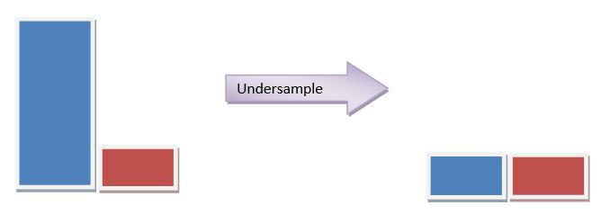

How does SMOTE work? – Let’s say our class proportion is as depicted in the figure below. SMOTE captures n-neighbours of the minority class and then compute its centroid. This newly generated centroid is the addition to the minority class.

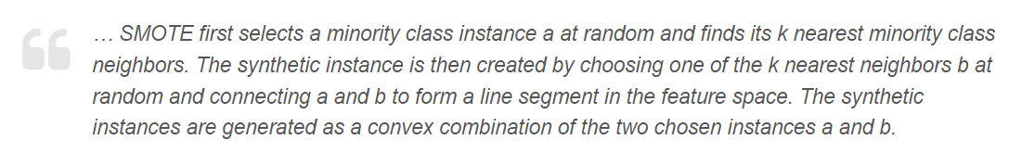

**Steps for SMOTE:**

1. **Select a minority class instance (a sample from the minority class) as the starting point.**
2. **Find the k nearest neighbors of the selected instance. The value of k is a user-defined parameter.**
3. **Randomly select one of the k nearest neighbors, and denote it as the nearest neighbor.**
4. **Generate a new synthetic sample by interpolating between the selected instance and the nearest neighbor. This is done by calculating the difference between the feature values of the two instances and multiplying it by a random number between 0 and 1. The resulting difference is added to the selected instance, creating a new synthetic sample.**
5. **Repeat steps 1 to 4 until the desired number of synthetic samples is generated.**

**Tips to use SMOTE:**

1. **Usually 5 neighbour clusters are chosen**
2. **Try not to go overboard. This means do not increase the minority class proportion for more than 5 or 10%. If increasing the minority class proportion to this level only increases your model performance, then it’s ok. Otherwise, try different models.**
3. Do not use SMOTE on test data.

# **Why to regularize the linear regression models?**

1. Size of the coefficients increase exponentially as the complexity of the model increases.

What does a large coefficient signify? It means that we’re putting a lot of emphasis on that feature, i.e. the particular feature is a good predictor for the outcome. When it becomes too large, the algorithm starts modelling intricate relations to estimate the output and ends up overfitting to the particular training data.

**Example of using ridge to handle multicollinearity:**

[**https://www.sas.com/content/dam/SAS/support/en/sas-global-forum-proceedings/2018/2825-2018.pdf**](https://www.sas.com/content/dam/SAS/support/en/sas-global-forum-proceedings/2018/2825-2018.pdf)

* **Ridge:** It generally works well even in presence of highly correlated features as it will include all of them in the model but the coefficients will be distributed among them depending on the correlation.
* **Lasso:** It arbitrarily selects any one feature among the highly correlated ones and reduced the coefficients of the rest to zero. Also, the chosen variable changes randomly with change in model parameters. This generally doesn’t work that well as compared to ridge regression.

# **Explanation of Hyperparameters:**

**XGBoost**:

* 1. **max_depth:** is the maximum number of nodes allowed from the root to the farthest leaf of a tree. Deeper trees can model more complex relationships by adding more nodes, but as we go deeper, splits become less relevant and are sometimes only due to noise, causing the model to overfit. **Ideally between 2-10**
  2. **learning_rate(referenced as eta in XGBoost)**: This controls the magnitude of the step size to reach minima of the cost function. This can also help to prevent overfitting. Smaller learning rate requires more number of trees. **Can be between 0.1 to 0.3. But can go lower.**
  3. **Gamma/min_split_loss**: This parameter can help to reduce overfitting and can be thought of as a complexity controller. **Range can be between 0 and infinity**.
  4. **Min_child_weight**: This can be termed as the number of samples required to form a leaf node. Setting it to a very low number might lead to overfitting and setting it to a very high number might lead to underfitting. **This can be an integer as well as a float. Setting it to .9 would mean that 90% of the samples need to be in a leaf in order for the leaf to be valid.**
  5. **Subsample ; colsample_by_tree ; colsample_by_level** : These features are used to make the trees random and decorrelated with each other.

‘***subsample***’: Fraction of the observations sampled from the training data to train the weak learners

‘***colsample_by_tree***’: Fraction of the features used to train each tree

‘***colsample_by_level***’: Fraction of the features (randomly selected) that will be used in each node to train each tree.

**Random forest**:

1. **n_estimators**: Increasing the number of trees does not overfit the model. One can fit as many trees as they want.

**Decision trees:**

1. criterion: {“gini” , “entropy” }
2. max_depth: is the maximum number of nodes allowed from the root to the farthest leaf of a tree. Deeper trees can model more complex relationships by adding more nodes, but as we go deeper, splits become less relevant and are sometimes only due to noise, causing the model to overfit. **Ideally between 2-10**
3. **Min_sample_split:** It is the minimum number of records that should be there in a node to qualify splitting it into further child nodes.
4. **Min_sample_leaf**: It is the minimum number of records that should be in a terminal node before it is termed as a leaf/terminal node. If the node has lesser records than this, then the complete split gets cancelled and the tree stops at the parent node of these two child nodes

**Note: Min_sample_leaf = There should be at least 1%-3% records(of the training dataset) in every terminal node if it is less than 1% my model might become overfitted.**

**Min_sample_split = 2 to 3 times of Min_sample_leaf**

**Decision trees regressor**:

1. The decision to find the best split is based on variance reduction i.e., just like for classification we were looking to split the root node basis the column or feature which had the maximum entropy reduction or gini impurity reduction or information gain or gini gain, in the case of regression, we use variance reduction
2. The decision is based on the average of the values of the target variable in the leaf node.

# **SHAPley value**: Shapley value is the average amount of contribution that a particular member makes to the coalition value.

SHAP helps us to assess the marginal contribution of a particular feature to its prediction. It stands for Shapley Additive Explanations.

It is a local explanation technique which means it tends to explain the outcome of one observation as a function of the value of each feature. However, it is possible to get the valid global explanation by aggregating the SHAP values for each observation.

**There can be three types of SHAP plots**:

1. Local importance plot also known as force plot.

**Tips for creating a good ML model**

1. Study the dependent variable. Assess if it is skewed which means if it comes primarily from one category only
2. See if Normalization or Standardization is necessary.
3. See if Outliers need to be capped
4. Feature engineering – We need to see which features are more capable of predicting the target variable than the others.

Using correlation coefficients for the feature with target variable, we can achieve this

1. Statistical tests - <https://www.analyticsvidhya.com/blog/2021/06/feature-selection-using-statistical-tests/>
2. Regularization of the model

# **SHAP:**